Lao People’s Democratic Republic
Peace Independence Democracy Unity Prosperity

REQUEST FOR QUOTATION
THE PROCUREMENT OF GOODS OR NON-CONSULTING SERVICES

​ HARMONIZED VERSION

Prepared by: Ministry of Finance
Supported by: Public Finance Management Reform Project
(Funded by the European Union and implemented by the World Bank)

​
August, 2021

Introduction

1 The Harmonized Request for Quotation for the Procurement of goods or Non-Consulting Services (Harmonized RFQ-SBD goods or Non-Consul) has been modified and edited from Request for Quotation for procurement of works 2015 edition jointly by the World Bank (WB), Asian Development Bank (ADB) and the Ministry of Finance (MoF) of the Lao PDR for use in smaller contracts through Request for Quotation (RFQ) for lumpsum or unit price base (unit prices in a bill of quantities) by using state budget such as government, loan and grant budget must be a unified manner countrywide of the implementation. This Harmonized Request for Quotation for Procurement of Works (Harmonized RFQ-SBD goods or non-Consult) is based on law procurement No 30/NA, dated 02 November 2017 and Instruction on implementation of law on public procurement No 0477/MOF, dated 13 February 2019.

2 This Harmonized Request for Quotation for Procurement of Works (Harmonized RFQ-SBD goods or Non-Consul) is using for small contracts, the Procurement Entity or Project owner shall be confident and ensure that the competition can easily select the constructor, the Procurement Entity or Project owner must be accepted only the winner that is considered the lowest evaluated price in line with the regulation specified in the procurement law and the instruction on implementation of law on public procurement, for the procurement implementation, the Procurement Entity or Project owner shall invite at least 3 qualified bidders or if advertisement through the media (newspaper, less than 3 submitted bidders is accepted).

3 This Harmonized Request for Quotation for Procurement of goods or Non-Consulting Services (Harmonized RFQ-SBD goods or non-Consul) is not required the Bid security, performance security and warranty for works and /or maintenance or services, however, in some kind of works or maintenance the Procuring Entity or Project owner considered there is a risk, the Bid security, performance security and warranty for works and /or maintenance or services shall be proposed.

4 This Harmonized Request for Quotation for Procurement of goods or Non-Consulting Services (Harmonized RFQ-SBD works) issued to the Procuring Entity or Project owner can improve and modify according to the need of each procurement.

Therefore, hopefully This Harmonized Request for Quotation for Procurement of goods or Non-Consulting Services (Harmonized RFQ-SBD goods or non-Consul) will help the Procuring Entity or Project owner have the facility in the preparation and make the corrected bidding documents in line with the law and its regulation.
Minister of Ministry of Finance

Lao People's Democratic Republic
Peace Independence Democracy Unity Prosperity
____________________
Insert Name of Ministry/Province
Insert Name of Procuring Entity
Insert Name of Project No.
Insert Contract No. Date:

Request for Quotation
To: Name and Address of the Supplier or Service provider

- [Insert Name of implementing Agency/Procuring Entity] will apply the State Budget for [FY] or [a part of a Grant or Loan from donor] to finance the procurement of [Name of the Goods or Non-Consulting service] under this Request for Quotation.

- [Insert Name of Procuring Entity] invites you to submit a sealed Quotation for the supply of [Insert Name of Goods or Non-Consulting service to be procured]. The delivery period is [Insert number of days/weeks/months].

- Bidding will be conducted through Request for Quotation procedure specified in the Law on Public Procurement Law No 30/NA, dated 2 Nov 2017 and the Instruction of Implementation of Law on Public Procurement, No. 0477/MOF, dated 13 Feb 2019.

- The Quotation shall be delivered before [Time and date] to [address], and all Quotations will be opened at [Time and date] in the presence of the Tender Committee and the Bidder’s representatives who choose to attend

Signature of authorized person and stamp

Name and Surname

Section 1: Instruction to the Bidders [ITB]

- Description of Goods: The [Procuring Entity] invites quotations for the Goods of [name of the Goods or Non-Consulting service]. The successful Bidder is expected to deliver the goods or Non-Consulting service within the time specified under Section 3: Condition of the Contract paragraph 6.

- Eligible Bidders:
The Bidder shall provide information specified in Section 2: Bidder Information Sheet (items 1-5).

- Fraud and Corruption:

- The Lao PDR Law on Anti-Corruption No. 03/NA – 19 May 2005
Article 2. Corruption
Corruption is the act of an official who opportunistically uses his position, powers, and duties to embezzle, swindle [or] receive bribes or any other act provided for in Article 10 of this law, [which act is committed] to benefit himself or his family, relatives, friends, clan, or group and causes damage to the interests of the State and society or to the rights and interests of citizens.
The official stipulated in this law means leaders at all levels, administrative staff, technical staff, the staff of State enterprises, civil servants, soldiers, [and] police officers, including chiefs of villages and persons who are officially authorized and assigned to exercise any right or duty.
Article 10. Acts that Constitute Corruption
Acts that constitute corruption can take the following forms:
- Embezzlement of State property or collective property;
- Swindling of State property or collective property;
- Taking bribes;
- Abuse of position, power, and duty to take State property, collective property or individual property;
- Abuse of State property or collective property;
- Excessive use of position, power, and duty to take State property, collective property or individual property;
- Cheating or falsification relating to technical construction standards, designs, calculations, and others;
- Deception in bidding or concessions;
- Forging documents or using forged documents;
- Disclosure of State secrets for personal benefit;
- Holding back or delaying documents.
- [For contract financed by the WB] the World Bank defines, for the purposes of this provision, the terms set forth below as follows:
- Purpose
  - The Bank’s Anti-Corruption Guidelines and this annex apply with respect to procurement under Bank Investment Project Financing operations.
- Requirements
- The Bank requires that Borrowers (including beneficiaries of Bank financing); bidders (applicants/proposers), consultants, contractors and suppliers; any sub-contractors, sub-consultants, service providers or suppliers; any agents (whether declared or not); and any of their personnel, observe the highest standard of ethics during the procurement process, selection and contract execution of Bank-financed contracts, and refrain from Fraud and Corruption.

- To this end, the Bank:
- Defines, for the purposes of this provision, the terms set forth below as follows:
- “corrupt practice” is the offering, giving, receiving, or soliciting, directly or indirectly, of anything of value to influence improperly the actions of another party;
- “fraudulent practice” is any act or omission, including misrepresentation, that knowingly or recklessly misleads, or attempts to mislead, a party to obtain financial or other benefit or to avoid an obligation;
- “collusive practice” is an arrangement between two or more parties designed to achieve an improper purpose, including to influence improperly the actions of another party;
- “coercive practice” is impairing or harming, or threatening to impair or harm, directly or indirectly, any party or the property of the party to influence improperly the actions of a party;
- “obstructive practice” is:
- deliberately destroying, falsifying, altering, or concealing of evidence material to the investigation or making false statements to investigators in order to materially impede a Bank investigation into allegations of a corrupt, fraudulent, coercive, or collusive practice; and/or threatening, harassing, or intimidating any party to prevent it from disclosing its knowledge of matters relevant to the investigation or from pursuing the investigation; or
- acts intended to materially impede the exercise of the Bank’s inspection and audit rights provided for under paragraph 2.2 e. below.
- Rejects a proposal for award if the Bank determines that the firm or individual recommended for award, any of its personnel, or its agents, or its sub-consultants, sub-contractors, service providers, suppliers and/ or their employees, has, directly or indirectly, engaged in corrupt, fraudulent, collusive, coercive, or obstructive practices in competing for the contract in question;
- In addition to the legal remedies set out in the relevant Legal Agreement, may take other appropriate actions, including declaring misprocurement, if the Bank determines at any time that representatives of the Borrower or of a recipient of any part of the proceeds of the loan engaged in corrupt, fraudulent, collusive, coercive, or obstructive practices during the procurement process, selection and/or execution of the contract in question, without the Borrower having taken timely and appropriate action satisfactory to the Bank to address such practices when they occur, including by failing to inform the Bank in a timely manner at the time they knew of the practices;
- Pursuant to the Banks Anti-Corruption Guidelines and in accordance with the Bank’s prevailing sanctions policies and procedures, may sanction a firm or individual, either indefinitely or for a stated period of time, including by publicly declaring such firm or individual ineligible (i) to be awarded or otherwise benefit from a Bank-financed contract, financially or in any other manner; (ii) to be a nominated sub-contractor, consultant, manufacturer or supplier, or service provider of an otherwise eligible firm being awarded a Bank-financed contract; and (iii) to receive the proceeds of any loan made by the Bank or otherwise to participate further in the preparation or implementation of any Bank-financed project;
- Requires that a clause be included in bidding/request for proposals documents and in contracts financed by a Bank loan, requiring (i) bidders (applicants/proposers), consultants, contractors, and suppliers: and their sub-contractors, sub-consultants, service providers, suppliers, agents, personnel, permit the Bank to inspect all accounts, records and other documents relating to the procurement process, selection and/or contract execution, and to have them audited by auditors appointed by the Bank.

- [For contract financed by the ADB] the ADB defines, for the purposes of this provision, the terms set forth below as follows:

- ADB’s anticorruption policy requires borrowers (including beneficiaries of ADB financed activity), as well as Bidders, suppliers, and contractors under ADB-financed contracts, observe the highest standard of ethics during the procurement and execution of such contracts. In pursuance of this policy,12 in the context of these Guidelines, ADB defines, for the purposes of this provision, the terms set forth below as follows:

- “corrupt practice” means the offering, giving, receiving, or soliciting, directly or indirectly, anything of value to influence improperly the actions of another party;
- “fraudulent practice” means any act or omission, including a misrepresentation, that knowingly or recklessly misleads, or attempts to mislead, a party to obtain a financial or other benefit or to avoid an obligation;
- “coercive practice” means impairing or harming, or threatening to impair or harm, directly or indirectly, any party or the property of the party to influence improperly the actions of a party;
- “collusive practice” means an arrangement between two or more parties designed to achieve an improper purpose, including influencing improperly the actions of another party;
- “Integrity violation” means any act, as defined under ADB’s Integrity Principles and Guidelines, which violates ADB’s Anticorruption Policy including corrupt, fraudulent, coercive, or collusive practice, abuse, and obstructive practice.
- “obstructive practice” means (a) deliberately destroying, falsifying, altering or concealing of evidence material to an ADB investigation; (b) making false statements to investigators in order to materially impede an ADB investigation; (c) failing to comply with requests to provide information, documents or records in connection with an OAI investigation; (d) threatening, harassing, or intimidating any party to prevent it from disclosing its knowledge of matters relevant to the investigation or from pursuing the investigation, or (e) materially impeding ADB’s contractual rights of audit or access to information.
- will reject a proposal for award if it determines that the Bidder recommended for award has, directly or through an agent, engaged incorrupt, fraudulent, collusive, coercive, or obstructive practices or other integrity violations in competing for the contract in question;

- will cancel the portion of the financing allocated to a contract if it determines at any time that representatives of the borrower or of a beneficiary of ADB-financing engaged in corrupt, fraudulent, collusive, coercive or obstructive practices or other integrity violations during the procurement or the execution of that contract, without the borrower having taken timely and appropriate action satisfactory to ADB to remedy the situation;

- will impose remedial actions on a firm or an individual, at any time, in accordance with ADB’s Anticorruption Policy and Integrity Principles and Guidelines(both as amended from time to time), including declaring ineligible, either indefinitely or for a stated period of time, to participate in ADB financed, administered or supported activities or to benefit from an ADB financed, administered or supported contract, financially or otherwise, if it at any time determines that the firm or individual has, directly or through an agent, engaged in corrupt, fraudulent, collusive, or coercive or other prohibited practices; and

- will have the right to require that a provision be included in bidding documents and in contracts financed by ADB, requiring Bidders, suppliers and contractors to permit ADB or its representative to inspect their accounts and records and other documents relating to the bid submission and contract performance and to have them audited by auditors appointed by ADB.

- Content of the request for quotations:

Section 1: Instruction to Bidders
Section 2: Bidder Information Sheet
Section 3: Conditions of contract
Section 4: Quotation Submission Form
Section 5: Schedule of Items and Prices
Section 6: Technical Specification
Section 7: List of Goods and Delivery Schedule
Section 8: Drawing/Brochure
Section 9: Contract Forms
Form 1: Notification of Intention to Award (For WB and ADB)
Form 1(a) : Notification of Intention to Award (For State Budget)
Form 2: Notification of Award
Form 3: Contract Agreement

Remark: In case of Procuring Entity Considers the Manufacturer Authorization is needed, it is recommended to use the Manufacturer Authorization form from the Open Standard Bidding document for Procurement of goods.

- Documents comprising the Quotation: Quotation submitted by the Bidders shall comprise the following documents:

  - Quotation Form with an original letter naming the person authorised to sign on behalf of the Bidder.
  - Schedule of Items and Prices
  - Technical Specification of the Goods to be supplied
  - Bidder Information Sheet
  - List of Goods and Delivery Schedule
  - The appropriate original printed literature / brochures for the various items listed.

- Quotation and Evaluation criteria: The Bidder’s quotation shall be for all items required and specified in Section 5: Schedule of Items and Prices. The Procuring Entity has the right to reject quotations that:

- Do not respond to all the items specified in the Schedule of Items.
- The proposed technical specifications do not meet the requirements in a substantial way.

The Procuring Entity will award the contract to the Bidder whose quotation has been determined to be substantially responsive to the Request for Quotation and who has offered the lowest evaluated quotation.

- Validity of Quotation: The Quotation shall remain valid for the period of [Insert Number of days/weeks/months] after the deadline for submission of quotations specified in ITB 14

- Submission of Quotation: Each Bidder shall submit only one Quotation

- Currency of Quotation: All prices shall be quoted in Lao Kip.

- Bid Price: The quoted price shall include taxes including profit tax, duty, inland transportation, insurance and costs incidental to delivery of the goods to their final destination. The quoted price shall be fixed for the duration of contract.

- Warranty: Warranty at least [Insert Number of days/weeks/months].

- After sale Services (when applicable): The Supplier should also provide a priced schedule of consumables, spare parts and routine maintenance that are expected to be required on the basis of a normal utilization of the equipment over a period of [insert number of years].

- Preparation and Sealing of Quotation: The Bidder shall prepare one original of the documents comprising the quotation as described in ITB 4 and marked “Original”. In addition, the Bidder shall also submit [Insert number] copies and marked “Copy”. In the event of any discrepancy between the original and the copies, the original shall prevail. The original and each copy of the Quotation shall be typed or written in indelible ink and shall be signed by a person duly authorised to sign on behalf of the Bidder. The name and position held by each person signing the authorisation must be typed or printed below the signature. Any interlineations, erasures, or overwriting shall be valid only if they are signed or initialled by the person(s) signing the Quotation.

- Place and deadline of submission of Quotation: The Quotation shall be delivered no later than [insert time and date] to [address]. Any Quotation received after the deadline prescribed in this paragraph will be rejected and returned unopened to the Bidder.

- Bid Securing Declaration [for contract financed by state budget] - Bidders are required to provide bid/quotation securing declaration using the form under Section 4. According to the declaration, a bidder that withdraws or modifies his quotation during the quotation validity period, or refuses to sign a procurement contract in accordance with the Quotation documents while the quotation is still valid, agrees to not participate in future bid/quotation for a period of two (2) years as specified in the declaration.

- Modification and withdrawal of Quotations: The Bidder may withdraw its Quotation after submission, provided that written notice of the withdrawal is received by the Procuring Entity prior to the deadline for submission. No Quotations shall be modified after the deadline for submission of Quotations specified above in ITB 14. Withdrawal of a quotation between the deadline for submission of quotation and expiration of the validity may result in ineligibility of the Bidder.

- Opening of Quotations will be held on [(insert the same time and date as ITB 14], and place as specified in the request for Quotation in the presence of the Tender Committee and the Bidders’ representatives who choose to attend. The Bidders names, modifications or withdrawals, quotation prices, discounts will be announced at the opening. The Procuring Entity shall provide to all attendees written minutes of the bid opening. No bid shall be rejected at the bid opening, except for late quotations.

- Immediately after completion of the opening proceedings, a copy of the opening record shall be posted at a prominent location, accessible to the public, outside the office of the Procuring Entity and shall be retained at the same location until the contract award has been notified. A copy of the bid opening record shall be provided to all Bidders who submitted quotations.

- Confidential: After the opening of Quotations, information relating to the examination, clarification, and evaluation of Quotations and recommendations for award shall not be disclosed to Bidders or other persons not officially concerned with the evaluation process until after the award of the Contract is announced.

- Evaluation and Comparison of Quotation: The Procuring Entity will award the contract to the Bidder whose quotation has been determined to be substantially responsive to the Request for Quotation and who has offered the lowest evaluated quotation. In evaluating the quotations, the tender committee will determine for each quotation the evaluated price by adjusting the quotation by marking any correction for any arithmetic errors as follows:
  - Where there is a discrepancy between amount in figures and in words, the amount in word will govern,
  - Where there is a discrepancy between the unit rate and the line item total resulting from multiplying the unit rate by the quantity, the unit rate as quoted will govern, unless in the opinion of the Procuring Entity there is an obvious misplacement of the decimal point in the unit price, in which case the line item total as quoted shall govern and the unit price shall be corrected.

- The Procuring Entity’s right: Depending on the final requirement, the Procuring Entity may increase or decrease the quantity or items list by [insert number of percent]. If any such change causes an increase or decrease in the quantity or items list, the rationale for the change shall be specified in the bid evaluation report for the procurement. The Procuring Entity reserves the right to accept or reject any quotations, and to cancel the process of the competition and reject all quotations, at any time prior to the award of the contract, without thereby incurring any liability to affected Bidders or any obligation to inform the affected Bidders of grounds.

- Notification of Intention to Award:
A. (WB/ADB) Prior to the expiration of the period of validity of the quotation, the Procuring Entity shall send to each Bidder the Notification of Intention to Award the Contract to the successful Bidder by using the relevant form for Notification of Intention to Award FORM1-Section 9: Contract forms.
B. [for contract financed by state budget] Prior to the expiration of the period of validity of the quotation, the Procuring Entity shall send to each Bidder the Notification of Award the Contract to the successful Bidder by using the relevant form for Notification of Award FORM1(A)-Section 9: Contract forms.

- Complaints: Any Bidder has the right to complain, if it has suffered or may suffer loss or damage due to a breach of a duty imposed by the Procuring Entity based on the Law on Public Procurement No. 30/NA, date 2 November 2017 and Instruction of Implementation of Law on Public Procurement, Ministry of Finance No. 0477/MOF, 13 February 2019. The Complaint shall be submitted to the Procuring Entity and Public Procurement Division (PPD) of Ministry of Finance.

- Debriefing by the Procuring Entity (WB/ADB): On receipt of the Procuring Entity’s Notification of Intention to Award, an unsuccessful Bidder has three (3) Business Days to make a written request to the Procuring Entity for a debriefing. The Procuring Entity shall provide a debriefing to all unsuccessful Bidders whose request is received within this deadline. Where a request for debriefing is received within the deadline, the Procuring Entity shall provide a debriefing within five (5) Business Days, unless the Procuring Entity decides, for justifiable reasons, to provide the debriefing outside this timeframe. In that case, the standstill period shall automatically be extended until five (5) Business Days after such debriefing is provided. If more than one debriefing is so delayed, the standstill period shall not end earlier than five (5) Business Days after the last debriefing takes place. The Procuring Entity shall promptly inform, by the quickest means available, all Bidders of the extended standstill period. Where a request for debriefing is received by the Procuring Entity later than the three (3)-Business Day deadline, the Procuring Entity should provide the debriefing as soon as practicable, and normally no later than fifteen (15) Business Days from the date of publication of Public Notice of Award of contract. Requests for debriefing received outside the three (3)-day deadline shall not lead to extension of the standstill period. Debriefings of unsuccessful Bidders may be done in writing. The Bidders shall bear their own costs of attending such a debriefing meeting. The complaint should be copied to the relevant financial institutions (WB or ADB).

- Signing of Contract: Prior to the expiration of the Bid Validity Period and upon expiry of the Standstill Period, or any extension thereof, and upon satisfactorily addressing any complaint that has been filed within the Standstill Period, the Procuring Entity shall send to the successful Bidder the Notification of Award in Section 8 including the Contract Agreement. The successful Bidder shall sign, date and return to the Procuring Entity, the Contract Agreement within fourteen (14) days of its receipt.

- The signed Contract Agreement shall be registered by the Supplier, in accordance with the Instruction on Implementation of Law on Public Procurement.

- Publication of Contract Award (WB/ADB): Within fourteen (14) Business Days after the date of transmission of the Notification of Intention to Award, the Procuring Entity shall publish the Contract Award Notice on relevant ministry public website or Facebook page or Local newspaper as well as in a prominent location, accessible to the public, outside the office of the Procuring Entity, (a) name of each Bidder who submitted a bid; (b) prices as read out at quotation opening; (c) name and evaluated price of each quotation that was evaluated; (d) name of Bidders whose quotations were rejected and the reasons for rejection; (e) name of the winning Bidder, contract price, explanation if it is different from the quoted price, as well as the duration and summary scope of the contract awarded.

Section 2: Bidder Information Sheet

The Bidder is required to furnish:

- Bidder’s Legal Name, Address,
- Copy of Business Licenses
- Business Operating License year………, or Business Licence Extension Certification
- Tax payment Certificate [year……….] or Tax payment Extension and
- Original letter naming the person authorised to sign on behalf of the Bidder, if any.

Section 3: Conditions of Contract

- The following documents forming the contract shall be interpreted in the following order of priority:

  - the signed Contract Agreement
  - The conditions of contract
  - Schedule of Items and Prices
  - Technical Specification of the Goods
  - List of Goods and Delivery Schedule
  - The appropriate original printed literature / brochures for the various items listed.

- This Contract shall be amended only by written agreement between the Procuring Entity and the Supplier or Service provider.

- Fraud and Corruption:

- Law on Anti-Corruption No. 03/NA – 19 May 2005 [In case of State Budget Funding]
Article 2. Corruption
Corruption is the act of an official who opportunistically uses his position, powers, and duties to embezzle, swindle [or] receive bribes or any other act provided for in Article 10 of this law, [which act is committed] to benefit himself or his family, relatives, friends, clan, or group and causes damage to the interests of the State and society or to the rights and interests of citizens.
The official stipulated in this law means leaders at all levels, administrative staff, technical staff, the staff of State enterprises, civil servants, soldiers, [and] police officers, including chiefs of villages and persons who are officially authorized and assigned to exercise any right or duty.
Article 10. Acts that Constitute Corruption
Acts that constitute corruption can take the following forms:
- Embezzlement of State property or collective property;
- Swindling of State property or collective property;
- Taking bribes;
- Abuse of position, power, and duty to take State property, collective property or individual property;
- Abuse of State property or collective property;
- Excessive use of position, power, and duty to take State property, collective property or individual property;
- Cheating or falsification relating to technical construction standards, designs, calculations, and others;
- Deception in bidding or concessions;
- Forging documents or using forged documents;
- Disclosure of State secrets for personal benefit;
- Holding back or delaying documents.

II [For contract financed by the WB] the World Bank defines Fraud and Corruption, for the purposes of this provision, as the terms set forth below as follows:
- Purpose
  - The Bank’s Anti-Corruption Guidelines and this annex apply with respect to procurement under Bank Investment Project Financing operations.
- Requirements
- The Bank requires that Borrowers (including beneficiaries of Bank financing); bidders (applicants/proposers), consultants, contractors and suppliers; any sub-contractors, sub-consultants, service providers or suppliers; any agents (whether declared or not); and any of their personnel, observe the highest standard of ethics during the procurement process, selection and contract execution of Bank-financed contracts, and refrain from Fraud and Corruption.

- To this end, the Bank:
- Defines, for the purposes of this provision, the terms set forth below as follows:
- “corrupt practice” is the offering, giving, receiving, or soliciting, directly or indirectly, of anything of value to influence improperly the actions of another party;
- “fraudulent practice” is any act or omission, including misrepresentation, that knowingly or recklessly misleads, or attempts to mislead, a party to obtain financial or other benefit or to avoid an obligation;
- “collusive practice” is an arrangement between two or more parties designed to achieve an improper purpose, including to influence improperly the actions of another party;
- “coercive practice” is impairing or harming, or threatening to impair or harm, directly or indirectly, any party or the property of the party to influence improperly the actions of a party;
- “obstructive practice” is:
- deliberately destroying, falsifying, altering, or concealing of evidence material to the investigation or making false statements to investigators in order to materially impede a Bank investigation into allegations of a corrupt, fraudulent, coercive, or collusive practice; and/or threatening, harassing, or intimidating any party to prevent it from disclosing its knowledge of matters relevant to the investigation or from pursuing the investigation; or
- acts intended to materially impede the exercise of the Bank’s inspection and audit rights provided for under paragraph 2.2 e. below.
- Rejects a proposal for award if the Bank determines that the firm or individual recommended for award, any of its personnel, or its agents, or its sub-consultants, sub-contractors, service providers, suppliers and/ or their employees, has, directly or indirectly, engaged in corrupt, fraudulent, collusive, coercive, or obstructive practices in competing for the contract in question;
- In addition to the legal remedies set out in the relevant Legal Agreement, may take other appropriate actions, including declaring misprocurement, if the Bank determines at any time that representatives of the Borrower or of a recipient of any part of the proceeds of the loan engaged in corrupt, fraudulent, collusive, coercive, or obstructive practices during the procurement process, selection and/or execution of the contract in question, without the Borrower having taken timely and appropriate action satisfactory to the Bank to address such practices when they occur, including by failing to inform the Bank in a timely manner at the time they knew of the practices;
- Pursuant to the Banks Anti-Corruption Guidelines and in accordance with the Bank’s prevailing sanctions policies and procedures, may sanction a firm or individual, either indefinitely or for a stated period of time, including by publicly declaring such firm or individual ineligible (i) to be awarded or otherwise benefit from a Bank-financed contract, financially or in any other manner; (ii) to be a nominated sub-contractor, consultant, manufacturer or supplier, or service provider of an otherwise eligible firm being awarded a Bank-financed contract; and (iii) to receive the proceeds of any loan made by the Bank or otherwise to participate further in the preparation or implementation of any Bank-financed project;
- Requires that a clause be included in bidding/request for proposals documents and in contracts financed by a Bank loan, requiring (i) bidders (applicants/proposers), consultants, contractors, and suppliers: and their sub-contractors, sub-consultants, service providers, suppliers, agents, personnel, permit the Bank to inspect all accounts, records and other documents relating to the procurement process, selection and/or contract execution, and to have them audited by auditors appointed by the Bank.

III [For contract financed by the ADB] the Asia Development Bank (ADB) defines Fraud and Corruption, for the purposes of this provision, as the terms set forth below as follows:

- ADB’s anticorruption policy requires borrowers (including beneficiaries of ADB financed activity), as well as Bidders, suppliers, and contractors under ADB-financed contracts, observe the highest standard of ethics during the procurement and execution of such contracts. In pursuance of this policy,12 in the context of these Guidelines, ADB defines, for the purposes of this provision, the terms set forth below as follows:

- “Corrupt practice” means the offering, giving, receiving, or soliciting, directly or indirectly, anything of value to influence improperly the actions of another party;
- “Fraudulent practice” means any act or omission, including a misrepresentation, that knowingly or recklessly misleads, or attempts to mislead, a party to obtain a financial or other benefit or to avoid an obligation;

- “Coercive practice” means impairing or harming, or threatening to impair or harm, directly or indirectly, any party or the property of the party to influence improperly the actions of a party;

- “Collusive practice” means an arrangement between two or more parties designed to achieve an improper purpose, including influencing improperly the actions of another party;

- “integrity violation” means any act, as defined under ADB’s Integrity Principles and Guidelines, which violates ADB’s Anticorruption Policy including corrupt, fraudulent, coercive, or collusive practice, abuse, and obstructive practice.

- “obstructive practice” means (a) deliberately destroying, falsifying, altering or concealing of evidence material to an ADB investigation; (b) making false statements to investigators in order to materially impede an ADB investigation; (c) failing to comply with requests to provide information, documents or records in connection with an OAI investigation; (d) threatening, harassing, or intimidating any party to prevent it from disclosing its knowledge of matters relevant to the investigation or from pursuing the investigation, or (e) materially impeding ADB’s contractual rights of audit or access to information.

- will reject a proposal for award if it determines that the Bidder recommended for award has, directly or through an agent, engaged incorrupt, fraudulent, collusive, coercive, or obstructive practices or other integrity violations in competing for the contract in question;

- will cancel the portion of the financing allocated to a contract if it determines at any time that representatives of the borrower or of a beneficiary of ADB-financing engaged in corrupt, fraudulent, collusive, coercive or obstructive practices or other integrity violations during the procurement or the execution of that contract, without the borrower having taken timely and appropriate action satisfactory to ADB to remedy the situation;

- will impose remedial actions on a firm or an individual, at any time, in accordance with ADB’s Anticorruption Policy and Integrity Principles and Guidelines(both as amended from time to time), including declaring ineligible, either indefinitely or for a stated period of time, to participate in ADB financed, administered or supported activities or to benefit from an ADB financed, administered or supported contract, financially or otherwise, if it at any time determines that the firm or individual has, directly or through an agent, engaged in corrupt, fraudulent, collusive, or coercive or other prohibited practices; and

- will have the right to require that a provision be included in bidding documents and in contracts financed by ADB, requiring Bidders, suppliers and contractors to permit ADB or its representative to inspect their accounts and records and other documents relating to the bid submission and contract performance and to have them audited by auditors appointed by ADB.

- Price adjustment and variation: Price adjustment and variation are not applicable to this contract.

- Payment: The payment for the Supplier shall be made in Lao Kip by [transfer to the account of Contractor or by appropriate method of payment] within [number of days/weeks/months] of delivery of goods to the final destination and acceptance as specified in Clause 8 (packaging of goods) and clause 9 (Inspection). 100% of the contract price shall be paid against submission of the Certificate of Acceptance and invoice [one original and number of copies]. The payment method shall be made as specified in the Supplier’s invoice. Payment of VAT/Taxes and other impositions shown in the Supplier’s invoice shall be made in accordance with the current regulations, at the time of settlement of the invoice.

- Delivery time: All goods shall be delivered to the Procuring Entity within [insert number of [days/weeks/months] from date of contract signed.

- Late delivery: If the Supplier delivers the specified goods later than the delivery period specified in clause 6, the Procuring Entity has the right to reduce the payment to the supplier by [0.01 to 0.05%] of the total price of contract for each day of delay beyond the delivery time. The deduction is up to a maximum of the 10%, and then the Procuring Entity may terminate the contract.

- Packaging of goods: The Supplier shall warrant those goods are contained or packaged adequately to protect the goods from loss or damage when transporting to the final destination of delivery.

- Inspection: Within 3 days of delivery, the Procuring Entity shall inspect the goods delivered to ensure compliance with the requirement of contract. If no fault is found, a certificate of acceptance should be issued to the Supplier.

- Intellectual Property infringement: The Supplier warrants the use by the Procuring Entity of the goods sold under this contract does not infringe any patent, design, trade name or trademark. In addition, the supplier shall, pursuant to this warranty, indemnify, defend and hold the Procuring Entity harmless from any action or claim pertaining to the alleged infringement of patent, design, trade name or trade mark arising in connection with the goods sold under this contract.

- Warranty: The Supplier shall provide the warranty of [insert number months]. And if any faults are detected within the warranty period in the supplied/installed goods, the Supplier shall be bound to rectify the fault or replace the goods within [Insert Number] days.

- Termination of Contract: The Procuring Entity may, by written notice sent to the Supplier, terminate the Contract in whole or in part at any time for its convenience:

    - if the Supplier or Service provider fails to deliver any or all the goods or service within the time period(s) specified in this contract, or
    - if the Supplier or Service provider fails to perform any other obligation(s) under this contract, or
    - if the Supplier or Service provider, in either of the above circumstances does not cure its failure within a period of (3) three calendar days after receipt of a notice of default from the Procuring Entity specifying the nature of the default(s), or
    - if the Supplier or Service provider, in the judgment of the Procuring Entity, has engaged in any corrupt or fraudulent practices in competing for or in executing the tasks under this contract.

- Settlement of disputes: During contract implementation, if any dispute arises between the two parties, relating to any aspects of this Agreement, the parties shall first attempt to settle the dispute through mutual and amicable consultation. In the event of agreement not being reached, the complaint shall be submitted to the Procuring Entity and Public Procurement Division (PPD) of Ministry of Finance. If the procurement is financed by The World Bank and ADB or other financial institutions the complaint should also be copied to the concerned institution.

Section 4: Quotation Form

Insert Logo of the Company
Insert Address:  Request for Quotation No: | Date:
To:
[Insert Name and address of the Procuring Entity]

Having examined the Request for Quotations, the receipt of which is here by duly acknowledged. We, the undersigned, offer to supply [Insert name of contract] in conformity with the said Request for Quotation in total Price:

- [Insert Value in figures in Kip]
- [Insert Value in words in Kip]

We undertake, if our Quotation is accepted, to deliver the goods or service in [days/weeks / months] from the date of the signed contract, in accordance with the delivery time specified in clause 6 of the Conditions of Contract.

We are not participating as Bidders in more than one Quotation in this price comparison process. Our Quotation shall be valid for [number days] after the deadline for submission of Quotations.

We declare that ourselves and any Suppliers for any part of the Contract have not been declared ineligible by the Government and/or World Bank/ADB on charges of engagement in corrupt, fraudulent, collusive, coercive or obstructive practices. We, furthermore, pledge not to indulge such practices in the duration of the Contract.

We understand that your written Notification of Award shall constitute the acceptance of our Quotation and shall become a binding contract between us, until a formal contract is prepared and executed.

We understand that you are not bound to accept the lowest or any Quotation that you may receive.

Signature and Stamp of Supplier

Name of Supplier

[FOR STATE BUDGET ONLY]

Lao People's Democratic Republic
Peace Independence Democracy Unity Prosperity
____________________

Insert Name of Ministry/Province/Organizations
Insert Name of Procuring Entity
Insert Name of Project
Insert Contract No.
Bid Securing Declaration

To: [Procuring Entity]
We, the undersigned, declare that:
We understand that, according to your conditions, quotations must be supported by a Bid-Securing Declaration.
We accept that we will automatically be suspended from being eligible for bidding in any contract around the Country, financed by World Bank, ADB and Government of Lao PDR for the period of time of at least two years starting on [insert date], if we are in breach of our obligation(s) under the quotation conditions, because we:
- have withdrawn our Quotation during the period of quotation validity specified in the Letter of Quotation; or
- having been notified of the acceptance of our Quotation by the GoL during the period of the Quotation validity, (i) fail or refuse to execute the Contract.
We understand this Bid-Securing Declaration shall expire if we are not the successful Bidder, upon the earlier of (i) our receipt of your notification to us of the name of the successful Bidder; or (ii) twenty-eight days after the expiration of our Quotation.
Signed: [insert signature of person whose name and capacity are shown] In the capacity of
[insert legal capacity of person signing the Bid-Securing Declaration]
Name: [insert complete name of person signing the Bid-Securing Declaration]
Duly authorized to sign the bid for and on behalf of: [insert complete name of Bidder]
Dated on ____________ day of __________________, _______ [insert date of signing]

[Note: In case of a Joint Venture, the Bid-Securing Declaration must be in the name of all partners to the Joint Venture that submits the bid.]

Section 5: Schedule of Items and Prices

Item | Name of goods or Non-Consulting service and Description | Unit | Quantity  (1) | Unit Rate (Kip)  Included all duties and taxes, transportation, insurance to final destination  (2) | Total Amount  Kip  (3) = (1) x (2)
I | Total Cost
II | VAT 10% (Included total cost)
III | Contract Registration Fee
 | Grand Total (write in number)
 | Grand Total (write in word)

Delivery Offered | [Insert number of days/weeks/Months]
Warranty Provided | [(Insert number of days/weeks/Months]

NOTE: Note If the bidder dose not enter the value of item II, III, it is considered that those cost are included in the total of the contract price including the profit tax which shall be under responsibility of bidder.

Date:

Signature of Supplier and Stamp

Insert Name of Supplier or Service provider

The attachment: Ordinance of the President No.002 on the Fees and Service Charges

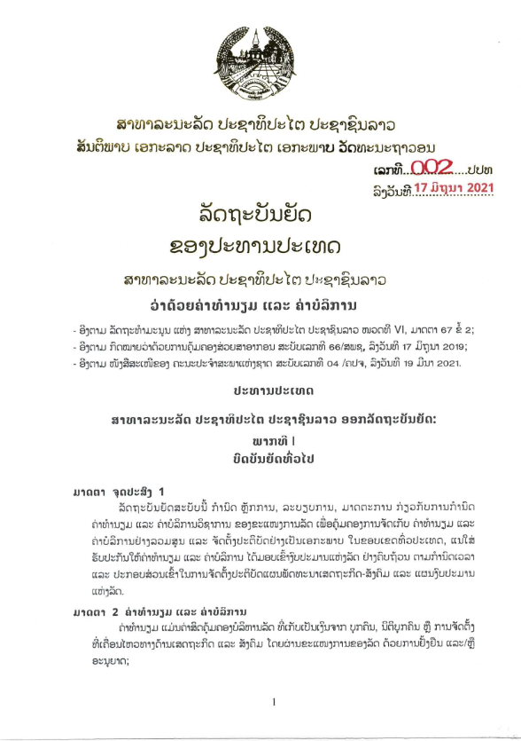
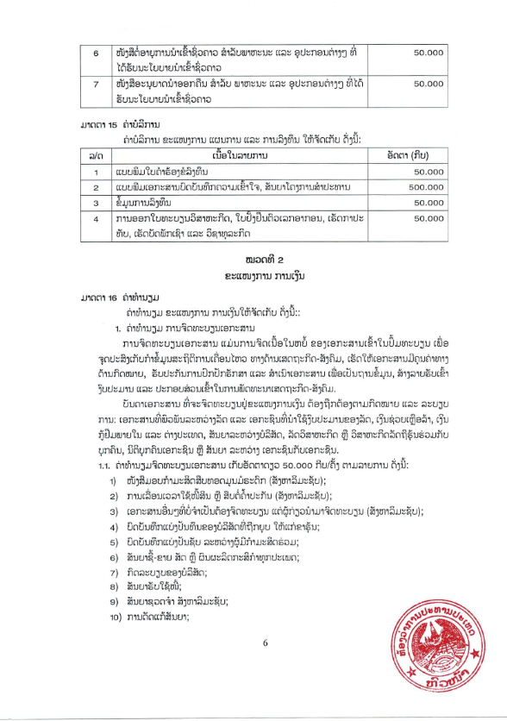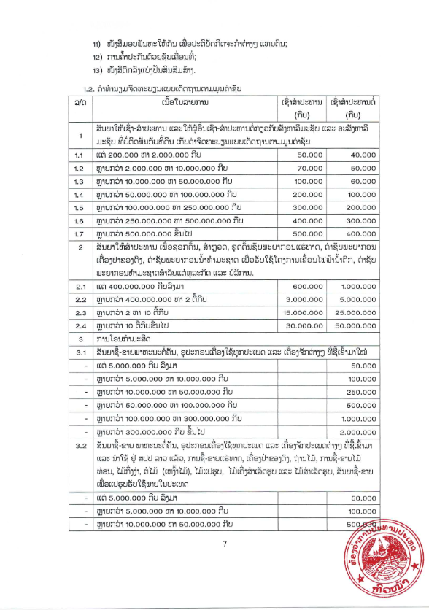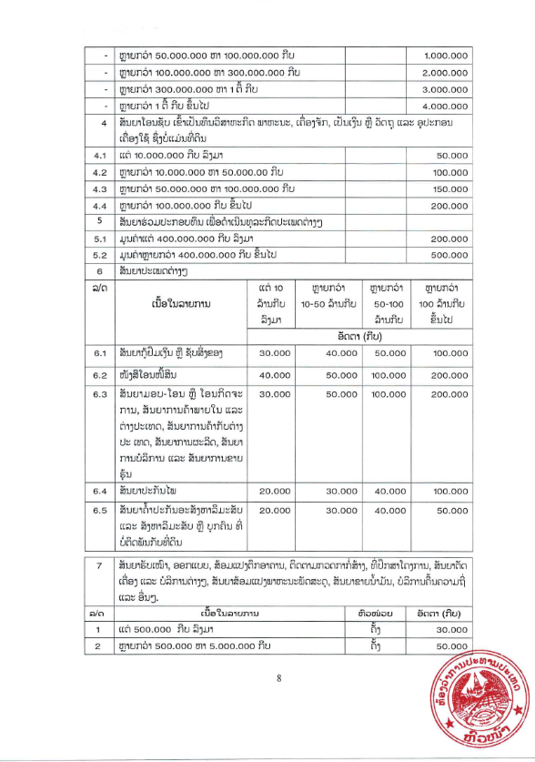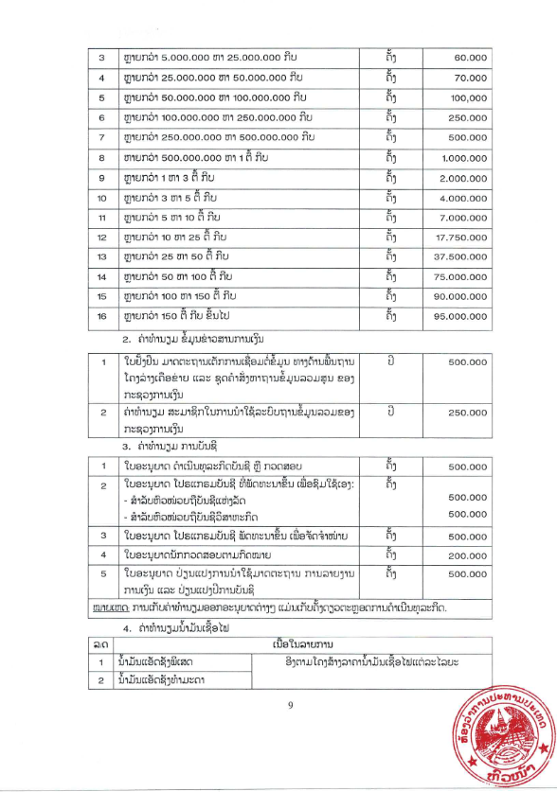

Section 6: Technical Specification of the Goods Required

Item | Name of goods or Non-Consulting service and Description | Technical Specification of Goods required | Technical Specification  of Goods to be offered

Signature and Stamp of Supplier or Service provider

Insert Name of Supplier or Service provider

Section 7: List of Goods and Delivery Schedule

Item | Name of goods or non-Consulting service and Description | Unit | Quantity | Point of Delivery | Date of Delivery (days/weeks/months)
1
2
3
4

Signature and Stamp of Supplier or Service provider

Insert Name of Supplier or Service provider

Section 8: Pictures of required goods

The Supplier is required to mention make or model, as applicable, of the goods to be supplied and must attach the appropriate original printed literature / brochures for the various items listed.

Section 9: Contract Forms

This Section contains forms which, once completed, will form part of the Contract.

Table of Content

Form 1: Notification of Intention to Award 32
Form 1 (a): Notification of Intention to Award (for state budget) 36
Form 2: Notification of Award 38
Form 3: Contract Agreement 39

(Proposal to use for WB and ADB)

Form 1: Notification of Intention to Award
[This Notification of Intention to Award shall be sent to each Bidder that submitted a Bid.]
[Send this Notification to the Bidder’s Authorized Representative named in the Bidder Information Form]
For the attention of Bidder’s Authorized Representative
Name: [insert Authorized Representative’s name]
Address: [insert Authorized Representative’s Address]
Telephone/Fax numbers: [insert Authorized Representative’s telephone/fax numbers]
Email Address: [insert Authorized Representative’s email address]
[IMPORTANT: insert the date that this Notification is transmitted to Bidders. The Notification must be sent to all Bidders simultaneously. This means on the same date and as close to the same time as possible.]
DATE OF TRANSMISSION: This Notification is sent by: [email/fax] on [date] (local time)
Notification of Intention to Award
Procuring Entity: [insert the name of the Procuring Entity]
Project: [insert name of project]
Contract title: [insert the name of the contract]
Country: [insert country where RFB is issued]
Loan No. /Credit No. / Grant No.: [insert reference number for loan/credit/grant]
RFB No: [insert RFB reference number from Procurement Plan]
This Notification of Intention to Award (Notification) notifies you of our decision to award the above contract. The transmission of this Notification begins the Standstill Period. During the Standstill Period you may:
- request a debriefing in relation to the evaluation of your Bid, and/or
- submit a Procurement-related Complaint in relation to the decision to award the contract.
- The successful Bidder
Name: | [insert name of successful Bidder]
Address: | [insert address of the successful Bidder]
Contract price: | [insert contract price of the successful Bid]
- Other Bidders [INSTRUCTIONS: insert names of all Bidders that submitted a Bid. If the Bid’s price was evaluated include the evaluated price as well as the Bid price as read out.]
Name of Bidder | Bid price | Evaluated Bid price  (if applicable)
[insert name] | [insert Bid price] | [insert evaluated price]
[insert name] | [insert Bid price] | [insert evaluated price]
[insert name] | [insert Bid price] | [insert evaluated price]
- Reason/s why your Bid was unsuccessful
[INSTRUCTIONS: State the reason/s why this Bidder’s Bid was unsuccessful. Do NOT include: (a) a point by point comparison with another Bidder’s Bid or (b) information that is marked confidential by the Bidder in its Bid.]
- How to request a debriefing
DEADLINE: The deadline to request a debriefing expires at midnight on [insert date] (local time).
You may request a debriefing in relation to the results of the evaluation of your Bid. If you decide to request a debriefing your written request must be made within three (3) Business Days of receipt of this Notification of Intention to Award.
Provide the contract name, reference number, name of the Bidder, contact details; and address the request for debriefing as follows:
Attention: [insert full name of person, if applicable]
Title/position: [insert title/position]
Agency: [insert name of Procuring Entity]
Email address: [insert email address]
If your request for a debriefing is received within the 3 Business Days deadline, we will provide the debriefing within five (5) Business Days of receipt of your request. If we are unable to provide the debriefing within this period, the Standstill Period shall be extended by five (5) Business Days after the date that the debriefing is provided. If this happens, we will notify you and confirm the date that the extended Standstill Period will end.
The debriefing may be in writing, by phone, video conference call or in person. We shall promptly advise you in writing how the debriefing will take place and confirm the date and time.
If the deadline to request a debriefing has expired, you may still request a debriefing. In this case, we will provide the debriefing as soon as practicable, and normally no later than fifteen (15) Business Days from the date of publication of the Contract Award Notice.
- How to make a complaint
Period: Procurement-related Complaint challenging the decision to award shall be submitted by midnight, [insert date] (local time).
Provide the contract name, reference number, name of the Bidder, contact details; and address the Procurement-related Complaint as follows:
Attention: [insert full name of person, if applicable]
Title/position: [insert title/position]
Agency: [insert name of Procuring Entity]
Email address: [insert email address]
At this point in the procurement process, you may submit a Procurement-related Complaint challenging the decision to award the contract. You do not need to have requested, or received, a debriefing before making this complaint. Your complaint must be submitted within the Standstill Period and received by us before the Standstill Period ends.
Further information:
For more information see the Procurement Regulations for IPF Borrowers (Procurement Regulations)[https://policies.worldbank.org/sites/ppf3/PPFDocuments/Forms/DispPage.aspx?docid=4005] (Annex III). You should read these provisions before preparing and submitting your complaint. In addition, the World Bank’s Guidance “How to make a Procurement-related Complaint” [http://www.worldbank.org/en/projects-operations/products-and-services/brief/procurement-new-framework#framework] provides a useful explanation of the process, as well as a sample letter of complaint.
In summary, there are four essential requirements:
- You must be an ‘interested party’. In this case, that means a Bidder who submitted a Bid in this bidding process and is the recipient of a Notification of Intention to Award.
- The complaint can only challenge the decision to award the contract.
- You must submit the complaint within the period stated above.
- You must include, in your complaint, all of the information required by the Procurement Regulations (as described in Annex III).
- Standstill Period
DEADLINE: The Standstill Period is due to end at midnight on [insert date] (local time).
The Standstill Period lasts ten (10) Business Days after the date of transmission of this Notification of Intention to Award.
The Standstill Period may be extended as stated in Section 4 above.
If you have any questions regarding this Notification, please do not hesitate to contact us.
On behalf of the Procuring Entity:
Signature: ______________________________________________
Name: ______________________________________________
Title/position: ______________________________________________
Telephone: ______________________________________________
Email

[FOR STATE BUDGET ONLY]
Form 2 (a): Notification of Intention to Award (for state budget)

Lao People's Democratic Republic
Peace, independence, democracy, unity, lasting culture

Notification of Intention to Award

Ministry .........................
Department .............................................
Name of Project Owner (Procurement-Provider) No. / ......
Vientiane Capital, Date

Notification of Intention to Award
[This Notification to successful and non-successful Bidders]
[Send this Notification to the Bidder’s Authorized Representative named in the Bidder Information Form]
For the attention of Bidder’s Authorized Representative
Name: [insert Authorized Representative’s name]
Address: [insert Authorized Representative’s Address]
Telephone [insert Authorized Representative’s telephone]
Email Address: [insert Authorized Representative’s email address]
[IMPORTANT: insert the date that this Notification is transmitted to Bidders. The Notification must be sent to all Bidders simultaneously. This means on the same date and as close to the same time as possible.]
DATE OF TRANSMISSION: This Notification is sent by: [email] on [date] [local time]

- According to the evaluation report No……………………………………………….
- According to the minutes of the meeting to approve the results of the bidding.
The Procurement Committee of [the Ministry or Department or the name of the project] would like to inform you about the results of the Procurement of [Name of the works], where the quotations were opened on [date] ........... Details are as follows:
The Successful Bidder
Name | Address | Contract Price

Other Bidders
Items | ​Name of /Bidders | ​Opening Bid Prices | ​Evaluation Prices | ​The Result | ​The reason of Failure
1
2
3
4

The Project Director of [ the Ministry or the Department or the name of the project owner] would like to thank all the Bidders that participated in this Procurement and we welcome you to express interest on future procurement opportunities.

The successful Bidder must sign a contract within 14 days.

If you have any concerns or do not feel that the results of the above assessment and decision to be fair, you can file a formal letter to the Procuring Entity of [the Ministry or Department or the name of the project owner] within 14 days of this notice. The complaints should be made in accordance with on the Law on Public Procurement and Instruction of Implementation of Law on Public Procurement, if the overdue complaint is deemed ineffective or not considered.

Chairman of the Procurement Committee
Form 3: Notification of Award
Lao People's Democratic Republic
Peace Independence Democracy Unity Prosperity

Notification of Award

Contract No: | Date:
To:

[enter name of Supplier]

This is to notify you that your quotation dated [insert date] for the procurement of the Goods for [name of project/Contract] for the Contract Price of Kip [amount in figures and words], as corrected and modified in accordance with the Instructions to Bidders is hereby accepted by [name of the Procuring Entity].

You are requested to proceed with the procurement of the Goods on the basis that this Notification of Award shall constitute the formation of a Contract, which shall only become binding upon you furnishing a Performance Security and an Environmental, Social, Health and Safety Performance Security [Delete ESHS Performance Security if it is not required under the contract] within fourteen (14) days, in accordance with ITB 20, and signing the Contract Agreement within fourteen (14) days.

We attach the draft Contract Agreement and Conditions of Contract for your perusal and signature.

Signature(s)
Duly authorised to sign for and on behalf of [Procuring Entity]

Form 4: Contract Agreement

Lao People's Democratic Republic
Peace Independence Democracy Unity Prosperity

Contract Agreement

THIS AGREEMENT is made the [day] day of [month] [year] between [insert name and address of Procuring Entity] (hereinafter called “the Procuring Entity”) and [insert name and address of Supplier] (hereinafter called “the Supplier”).

WHEREAS the Procuring Entity invited for quotation for insert name of contract) and has accepted a Quotation by the Supplier for the supply of those goods in the sum of Kip [insert Contract Price in figures and in words] (hereinafter called “the Contract Price”).

NOW THIS AGREEMENT WITNESS AS FOLLOWS:

Article 1. The documents forming the Contract shall be interpreted in the following order of priority:

(a) the signed Contract Agreement
(b) The conditions of contract
(c) Schedule of Items and Prices
(d) Technical Specification of the Goods Required
(e) List of Goods and Delivery Schedule.
    - The appropriate original printed literature / brochures for the various items listed.

Article 2. In consideration of the payments to be made by the Procuring Entity to the Supplier as hereinafter mentioned, the Supplier hereby covenants with the Procuring Entity to provide the goods and related services and to remedy any defects therein in conformity in all respects with the provisions of the Contract.

Article 3. The Procuring Entity hereby covenants to pay the Supplier in consideration of the provision of the goods and related services and the remedying of defects therein, the Contract Price or such other sum as may become payable under the provisions of the Contract at the time and in the manner prescribed by the Contract.

IN WITNESS whereof the parties hereto have caused this Agreement to be executed in accordance with the laws of Lao PDR on the day, month and year first written above.

Signed, Sealed and delivered by the said Signed, Sealed and delivered by the said

In the presence of (for Procuring Entity) In the presence of (for Contractor)

Witness:

…………………………….. …………………………………...

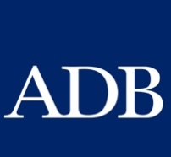
Ministry of Finance
State Assets Management Department
Road 23 Singha, Vientiane Capital, Lao PDR
Tel/Fax: (856-21) 263252
www.ppd.mof.gov.la

For the avoidance of doubt, a sanctioned party’s ineligibility to be awarded a contract shall include, without limitation, (i) applying for pre-qualification, expressing interest in a consultancy, and bidding, either directly or as a nominated sub-contractor, nominated consultant, nominated manufacturer or supplier, or nominated service provider, in respect of such contract, and (ii) entering into an addendum or amendment introducing a material modification to any existing contract.
A nominated sub-contractor, nominated consultant, nominated manufacturer or supplier, or nominated service provider (different names are used depending on the particular bidding document) is one which has been: (i) included by the bidder in its pre-qualification application or bid because it brings specific and critical experience and know-how that allow the bidder to meet the qualification requirements for the particular bid; or (ii) appointed by the Borrower.
Inspections in this context usually are investigative (i.e., forensic) in nature. They involve fact-finding activities undertaken by the Bank or persons appointed by the Bank to address specific matters related to investigations/audits, such as evaluating the veracity of an allegation of possible Fraud and Corruption, through the appropriate mechanisms. Such activity includes but is not limited to: accessing and examining a firm's or individual's financial records and information, and making copies thereof as relevant; accessing and examining any other documents, data and information (whether in hard copy or electronic format) deemed relevant for the investigation/audit, and making copies thereof as relevant; interviewing staff and other relevant individuals; performing physical inspections and site visits; and obtaining third party verification of information.
For the avoidance of doubt, a sanctioned party’s ineligibility to be awarded a contract shall include, without limitation, (i) applying for pre-qualification, expressing interest in a consultancy, and bidding, either directly or as a nominated sub-contractor, nominated consultant, nominated manufacturer or supplier, or nominated service provider, in respect of such contract, and (ii) entering into an addendum or amendment introducing a material modification to any existing contract.
A nominated sub-contractor, nominated consultant, nominated manufacturer or supplier, or nominated service provider (different names are used depending on the particular bidding document) is one which has been: (i) included by the bidder in its pre-qualification application or bid because it brings specific and critical experience and know-how that allow the bidder to meet the qualification requirements for the particular bid; or (ii) appointed by the Borrower.
Inspections in this context usually are investigative (i.e., forensic) in nature. They involve fact-finding activities undertaken by the Bank or persons appointed by the Bank to address specific matters related to investigations/audits, such as evaluating the veracity of an allegation of possible Fraud and Corruption, through the appropriate mechanisms. Such activity includes but is not limited to: accessing and examining a firm's or individual's financial records and information, and making copies thereof as relevant; accessing and examining any other documents, data and information (whether in hard copy or electronic format) deemed relevant for the investigation/audit, and making copies thereof as relevant; interviewing staff and other relevant individuals; performing physical inspections and site visits; and obtaining third party verification of information.
The unit price shall include all taxes, duties, inland transportation and cost incidental to delivery, as well as insurance to final destination.
The contract registration fee is in accordance with Ordinances of the President No.002 in the attachment

