Lao People’s Democratic Republic
Peace Independence Democracy Unity Prosperity

REQUEST FOR QUOTATION
THE PROCUREMENT OF WORKS

​ HARMONIZED VERSION

Printed by: Ministry of Finance
Supported by: Public Finance Management Reform Project
(Funded by the European Union and implemented by the World Bank)

​ August, 2021

Introduction

1 The Harmonized Request for Quotation for the Procurement of Works (Harmonized RFQ-SBD works) has been modified and edited from Request for Quotation for procurement of works 2015 edition jointly by the World Bank (WB), Asian Development Bank (ADB) and the Ministry of Finance (MoF) of the Lao PDR for use in smaller contracts through Request for Quotation (RFQ) for lumpsum or unit price base (unit prices in a bill of quantities) by using state budget such as government, loan and grant budget must be a unified manner countrywide of the implementation. This Harmonized Request for Quotation for Procurement of Works (Harmonized RFQ-SBD works) is based on law procurement No 30/NA, dated 02 November 2017 and Instruction on implementation of law on public procurement No 0477/MOF, dated 13 February 2019.

2 This Harmonized Request for Quotation for Procurement of Works (Harmonized RFQ-SBD works) is using for small contracts, the Procurement Entity or Project owner shall be confident and ensure that the competition can easily select the constructor, the Procurement Entity or Project owner must be accepted only the winner that is considered the lowest evaluated price inline with the regulation specified in the procurement law and the instruction on implementation of law on public procurement, for the procurement implementation, the Procurement Entity or Project owner shall invite at least 3 qualified bidders or if advertisement through the media (newspaper, less than 3 submitted bidders is accepted).

3 This Harmonized Request for Quotation for Procurement of Works (Harmonized RFQ-SBD works) is not required the Bid security, performance security and warranty for works and
/or maintenance or services, however, in some kind of works or maintenance the Procuring Entity or Project owner considered there is a risk, the Bid security, performance security and warranty for works and /or maintenance or services shall be proposed.

4 This Harmonized Request for Quotation for Procurement of Works (Harmonized RFQ-SBD works) issued to the Procuring Entity or Project owner can improve and modify according to the need of each procurement.

Therefore, hopefully This Harmonized Request for Quotation for Procurement of Works (Harmonized RFQ-SBD works) will help the Procuring Entity or Project owner have the facility in the preparation and make the corrected bidding documents inline with the law and its regulation.

Minister of Ministry of Finance
.

Lao People's Democratic Republic
Peace Independence Democracy Unity Prosperity
____________________

Insert Name of Ministry/Province
Insert Name of Procuring Entity
Insert Name of Project No.
Insert Contract No. Date:

Request for Quotation

To: Name and Address of the Contractor

1. [Insert Name of Procuring Entity] will apply [the State Budget for FY] or [a part of a Grant or Loan from donor] to finance the procurement of [Name of the Work] under this Request for Quotation.

2. [Insert Name of Procuring Entity] invites your Company to submit sealed quotation for [Insert the works to be procured]. The construction period is [Insert numbers of days/weeks/months].
3. Bidding will be conducted through Request for Quotation procedure specified in the Law on Public Procurement Law No 30/NA, dated 2 Nov 2017 and the Instruction of Implementation of Law on Public Procurement, No 0477/MOF, dated 13 Feb 2019.

4. The Quotation shall be delivered before [Time and date] to [address], and all Quotations will be opened at [Time and date] in the presence of the Tender Committee and the Bidder’s representatives who choose to attend.

Signature of authorized person and stamp

Name and Surname, Tel./Email
Section 1: Instruction to Bidders

- Description of Works: The [Procuring Entity] invites quotations for the construction of [name of the works]. The successful Bidder will be expected to construct the works within the time specified under Section 3: Condition of the Contract paragraph 8.

- Eligible Bidders:
The Bidder shall provide information specified in Section 2: Bidder Information Sheet (items 1-4).
- Fraud and Corruption:
[For contract financed by State Budget]
- The Lao PDR Law on Anti-Corruption No. 03/PO – 19 May 2005
Article 2. Corruption
Corruption is the act of an official who opportunistically uses his position, powers, and duties to embezzle, swindle [or] receive bribes or any other act provided for in Article 10 of this law, [which act is committed] to benefit himself or his family, relatives, friends, clan, or group and causes damage to the interests of the State and society or to the rights and interests of citizens.
The official stipulated in this law means leaders at all levels, administrative staff, technical staff, the staff of State enterprises, civil servants, soldiers, [and] police officers, including chiefs of villages and persons who are officially authorized and assigned to exercise any right or duty.
Article 10. Acts that Constitute Corruption
Acts that constitute corruption can take the following forms:
- Embezzlement of State property or collective property;
• Swindling of State property or collective property;
• Taking bribes;
• Abuse of position, power, and duty to take State property, collective property or individual property;
• Abuse of State property or collective property;
• Excessive use of position, power, and duty to take State property, collective property or individual property;
• Cheating or falsification relating to technical construction standards, designs, calculations, and others;
· Deception in bidding or concessions;
• Forging documents or using forged documents;
• Disclosure of State secrets for personal benefit;
• Holding back or delaying documents.
- [For contract financed by the World Bank] the World Bank defines, for the purposes of this provision, the terms set forth below as follows:
- Purpose
  - The Bank’s Anti-Corruption Guidelines and this annex apply with respect to procurement under Bank Investment Project Financing operations.
- Requirements
- The Bank requires that Borrowers (including beneficiaries of Bank financing); bidders (applicants/proposers), consultants, contractors and suppliers; any sub-contractors, sub-consultants, service providers or suppliers; any agents (whether declared or not); and any of their personnel, observe the highest standard of ethics during the procurement process, selection and contract execution of Bank-financed contracts, and refrain from Fraud and Corruption.

- To this end, the Bank:
- Defines, for the purposes of this provision, the terms set forth below as follows:
- “corrupt practice” is the offering, giving, receiving, or soliciting, directly or indirectly, of anything of value to influence improperly the actions of another party;
- “fraudulent practice” is any act or omission, including misrepresentation, that knowingly or recklessly misleads, or attempts to mislead, a party to obtain financial or other benefit or to avoid an obligation;
- “collusive practice” is an arrangement between two or more parties designed to achieve an improper purpose, including to influence improperly the actions of another party;
- “coercive practice” is impairing or harming, or threatening to impair or harm, directly or indirectly, any party or the property of the party to influence improperly the actions of a party;
- “obstructive practice” is:
- deliberately destroying, falsifying, altering, or concealing of evidence material to the investigation or making false statements to investigators in order to materially impede a Bank investigation into allegations of a corrupt, fraudulent, coercive, or collusive practice; and/or threatening, harassing, or intimidating any party to prevent it from disclosing its knowledge of matters relevant to the investigation or from pursuing the investigation; or
- acts intended to materially impede the exercise of the Bank’s inspection and audit rights provided for under paragraph 2.2 e. below.
- Rejects a proposal for award if the Bank determines that the firm or individual recommended for award, any of its personnel, or its agents, or its sub-consultants, sub-contractors, service providers, suppliers and/ or their employees, has, directly or indirectly, engaged in corrupt, fraudulent, collusive, coercive, or obstructive practices in competing for the contract in question;
- In addition to the legal remedies set out in the relevant Legal Agreement, may take other appropriate actions, including declaring misprocurement, if the Bank determines at any time that representatives of the Borrower or of a recipient of any part of the proceeds of the loan engaged in corrupt, fraudulent, collusive, coercive, or obstructive practices during the procurement process, selection and/or execution of the contract in question, without the Borrower having taken timely and appropriate action satisfactory to the Bank to address such practices when they occur, including by failing to inform the Bank in a timely manner at the time they knew of the practices;
- Pursuant to the Banks Anti-Corruption Guidelines and in accordance with the Bank’s prevailing sanctions policies and procedures, may sanction a firm or individual, either indefinitely or for a stated period of time, including by publicly declaring such firm or individual ineligible (i) to be awarded or otherwise benefit from a Bank-financed contract, financially or in any other manner; (ii) to be a nominated sub-contractor, consultant, manufacturer or supplier, or service provider of an otherwise eligible firm being awarded a Bank-financed contract; and (iii) to receive the proceeds of any loan made by the Bank or otherwise to participate further in the preparation or implementation of any Bank-financed project;
- Requires that a clause be included in bidding/request for proposals documents and in contracts financed by a Bank loan, requiring (i) bidders (applicants/proposers), consultants, contractors, and suppliers: and their sub-contractors, sub-consultants, service providers, suppliers, agents, personnel, permit the Bank to inspect all accounts, records and other documents relating to the procurement process, selection and/or contract execution, and to have them audited by auditors appointed by the Bank.

- [For contract financed by the ADB] the ADB defines, for the purposes of this provision, the terms set forth below as follows:
- ADB’s anticorruption policy requires borrowers (including beneficiaries of ADB financed activity), as well as Bidders, suppliers, and contractors under ADB-financed contracts, observe the highest standard of ethics during the procurement and execution of such contracts. In pursuance of this policy,12 in the context of these Guidelines, ADB defines, for the purposes of this provision, the terms set forth below as follows:

- “Corrupt practice” means the offering, giving, receiving, or soliciting, directly or indirectly, anything of value to influence improperly the actions of another party;
- “Fraudulent practice” means any act or omission, including a misrepresentation, that knowingly or recklessly misleads, or attempts to mislead, a party to obtain a financial or other benefit or to avoid an obligation;
- “Coercive practice” means impairing or harming, or threatening to impair or harm, directly or indirectly, any party or the property of the party to influence improperly the actions of a party;
- “Collusive practice” means an arrangement between two or more parties designed to achieve an improper purpose, including influencing improperly the actions of another party;
- “Integrity violation” means any act, as defined under ADB’s Integrity Principles and Guidelines, which violates ADB’s Anticorruption Policy including corrupt, fraudulent, coercive, or collusive practice, abuse, and obstructive practice.
- “obstructive practice” means (a) deliberately destroying, falsifying, altering or concealing of evidence material to an ADB investigation; (b) making false statements to investigators in order to materially impede an ADB investigation; (c) failing to comply with requests to provide information, documents or records in connection with an OAI investigation; (d) threatening, harassing, or intimidating any party to prevent it from disclosing its knowledge of matters relevant to the investigation or from pursuing the investigation, or (e) materially impeding ADB’s contractual rights of audit or access to information.
- will reject a proposal for award if it determines that the Bidder recommended for award has, directly or through an agent, engaged incorrupt, fraudulent, collusive, coercive, or obstructive practices or other integrity violations in competing for the contract in question;

- will cancel the portion of the financing allocated to a contract if it determines at any time that representatives of the borrower or of a beneficiary of ADB-financing engaged in corrupt, fraudulent, collusive, coercive or obstructive practices or other integrity violations during the procurement or the execution of that contract, without the borrower having taken timely and appropriate action satisfactory to ADB to remedy the situation;

- will impose remedial actions on a firm or an individual, at any time, in accordance with ADB’s Anticorruption Policy and Integrity Principles and Guidelines(both as amended from time to time), including declaring ineligible, either indefinitely or for a stated period of time, to participate in ADB financed, administered or supported activities or to benefit from an ADB financed, administered or supported contract, financially or otherwise, if it at any time determines that the firm or individual has, directly or through an agent, engaged in corrupt, fraudulent, collusive, or coercive or other prohibited practices; and

- will have the right to require that a provision be included in bidding documents and in contracts financed by ADB, requiring Bidders, suppliers and contractors to permit ADB or its representative to inspect their accounts and records and other documents relating to the bid submission and contract performance and to have them audited by auditors appointed by ADB.

- Content of the request for quotation:
Section 1: Instructions to Bidders
Section 2: Bidder Information Sheet
Section 3: Conditions of Contract
Section 4: Quotation Submission Form
Section 5: Schedule of Activities.
Section 6: Technical Specification and Work Schedule
Section 7: Drawings
Section 8: Contract Forms
Form 1 – Notification of Intention to Award (for WB and ADB)
Form 1 (A) – Notification of Intention to Award (for State Budget)
Form 2 – Beneficial Ownership Disclosure Form
Form 3 – Notification of Award
Form 4 – Contract Agreement
Form 5 – Bank Guarantee for Performance Security (If not required, delete it)
Form 6 – Bank Guarantee for supply of Works and/or maintenance or services
Documents comprising the Quotation: Quotation submitted by the Bidders shall comprise the following documents:

(a) Quotation Form with an original letter naming the person authorised to sign on behalf of the Bidder.
(b) Schedule of Activities.
(c) Construction Program and Work Schedule.
(d) Bidder Information Sheet

- Validity of Quotation: The Quotation shall remain valid for the period of [Insert Number of days/weeks/months] after the deadline for submission of quotation as specified in ITB 12.

- Submission of Quotation: Each Bidder shall submit only one Quotation.

- Currency of Quotation: All prices shall be quoted in Lao Kip.

- Bid Price: The Contract shall be for the whole works as described in the schedule of activity, drawings and technical specifications. Corrections, if any, shall be made by crossing out, initialing, dating, and rewriting. All duties, taxes including profit tax and other levies payable by the Contractor under the Contract shall be included in the total price. The rates quoted by the Bidder shall be fixed for the duration of the Contract and shall not be subject to adjustment on any account.

- Site Visit: The Bidder is advised to visit the site of works at his own expense and obtain all information that may be necessary for preparing the Quotation.

- Preparation and Sealing of Quotation: The Bidder shall prepare one original of the documents comprising the Quotation as described in ITB 5 of these instructions and marked “Original”. In addition, the Bidder shall also submit [Insert number] Copies. In the event of any discrepancy between the original and the copies, the original shall prevail.
The original and each copy of the Quotation shall be typed or written in indelible ink and shall be signed by a person duly authorised to sign on behalf of the Bidder. The name and position held by each person signing the authorisation must be typed or printed below the signature. Any interlineations, erasures, or overwriting shall be valid only if they are signed or initialled by the person(s) signing the Quotation.

- Place and deadline of submission of Quotation: The Quotation shall be delivered no later than [insert time and date] to [address]. Any Quotation received after the deadline prescribed in this paragraph will be rejected and returned unopened to the Bidder.

- Bid Securing Declaration [for contract financed by state budget] - Bidders are required to provide bid/quotation securing declaration using the form under Section 4. According to the declaration, a bidder that withdraws or modifies his quotation during the quotation validity period, or refuses to sign a procurement contract in accordance with the Quotation documents while the quotation is still valid, agrees to not participate in future bid/quotation which is funded by WB, ADB and Government budget for a period of at least two (2) years as specified in the declaration.

- Modification and withdrawal of Quotations: The Bidder may withdraw its Quotation after submission, provided that written notice of the withdrawal is received by Procuring Entity prior to the deadline for submission. No Quotations shall be modified after the deadline for submission of Quotations as specified in ITB 12. Withdrawal of a Quotation between the deadline for submission and expiration of the validity shall result in ineligibility of the Bidder.

- Opening of Quotation will be held on [insert the same time and date as in ITB 12] and place as specified in the request for Quotation in the presence of the Tender Committee and the Bidders’ representatives who choose to attend. The Bidders names, modification or withdrawals, Quotation prices, discounts will be announced at the opening. Procuring Entity shall provide all attendees with written minutes of the quotation opening. No quotation shall be rejected at the bid Opening, except for late quotations.

- Immediately after completion of the opening proceedings, a copy of the opening record shall be posted at a prominent location, accessible to the public, outside the office of Procuring Entity and shall be retained at the same location until the award of contract has been notified. A copy of the quotation opening record shall be provided to all Bidders who submitted Quotations.

- Confidential: After the opening of Quotations, information relating to the examination, clarification, and evaluation of Quotations and recommendations for award shall not be disclosed to Bidders or other persons not officially concerned with the evaluation process until after the award of the Contract is announced.

- Evaluation and Comparison of Quotations: Procuring Entity will award the contract to the Bidder whose quotation has been determined to be substantially responsive to the Request for Quotations and who has offered the lowest evaluated price. In evaluating the quotations, the tender committee will determine for each quotation the evaluated price by adjusting the quotation and marking any arithmetic errors as follows:
(a) Where there is a discrepancy between amount in figures and in words, the amount in word will govern;
(b) Where there is a discrepancy between the unit rate and the line-item total resulting from multiplying the unit rate by the quantity, the unit rate as quoted will govern. Unless in the opinion of the Procuring Entity there is an obvious misplacement of the decimal point in the unit price, in which case the line-item total as quoted shall govern and the unit price shall be corrected.

19. Procuring Entity’s right: Depending on the final requirement, the Procuring Entity may increase or decrease the items or quantities or tasks by [insert number of percent]. If any such change causes an increase or decrease in the quantity or items list, the rationale for the change shall be specified in the bid evaluation report for the procurement. The Procuring Entity reserves the right to accept or reject any Quotations, and to cancel the process of the competition and reject all Quotations, at any time prior to contract award, without thereby incurring any liability to affected Bidders or any obligation to inform the affected Bidders of grounds.
20. Notification of Intention to Award/Notification of Award:
A. [WB/ADB] Prior to the expiration of the period of validity of the quotation, the Procuring Entity shall send to each Bidder the Notification of Intention to Award the Contract to the successful Bidder by using the relevant form for Notification of Intention to Award FORM1-Section 8: Contract forms.
B. [for contract financed by state budget] Prior to the expiration of the period of validity of the quotation, the Procuring Entity shall send to each Bidder the Notification of Award the Contract to the successful Bidder by using the relevant form for Notification of Award FORM1(A)-Section 8: Contract forms.

21. Complaints: Any Bidder has the right to complain, if it has suffered or may suffer loss or damage due to a breach of a duty imposed by the Procuring Entity pursuant to the Law No 30/NA, dated 2 Nov 2017 and Instruction No 0477/, dated 13 Feb 2019.
.
22. Debriefing by the Procuring Entity (WB/ADB) On receipt of the Procuring Entity’s Notification of Intention to Award, an unsuccessful Bidder has three (3) Business Days to make a written request to the Procuring Entity for a debriefing. The Procuring Entity shall provide a debriefing to all unsuccessful Bidders whose request is received within this deadline. Where a request for debriefing is received within the deadline, the Procuring Entity shall provide a debriefing within five (5) Business Days, unless the Procuring Entity decides, for justifiable reasons, to provide the debriefing outside this timeframe. In that case, the standstill period shall automatically be extended until five (5) Business Days after such debriefing is provided. If more than one debriefing is so delayed, the standstill period shall not end earlier than five (5) Business Days after the last debriefing takes place. The Procuring Entity shall promptly inform, by the quickest means available, all Bidders of the extended standstill period. Where a request for debriefing is received by the Procuring Entity later than the three (3)-Business Day deadline, the Procuring Entity should provide the debriefing as soon as practicable, and normally no later than fifteen (15) Business Days from the date of publication of Public Notice of Award of contract. Requests for debriefing received outside the three (3)-day deadline shall not lead to extension of the standstill period. Debriefings of unsuccessful Bidders may be done in writing. The Bidders shall bear their own costs of attending such a debriefing meeting. The complaint should be copied to the relevant financial institutions (WB or ADB).
23. Signing of Contract: Prior to the expiration of the Bid Validity Period and upon expiry of the Standstill Period, or any extension thereof, and upon satisfactorily addressing any complaint that has been filed within the Standstill Period, the Procuring Entity shall send to the successful Bidder the Notification of Award in Section 8 including the Contract Agreement. The successful Bidder shall sign, date and return to the Procuring Entity, the Contract Agreement within fourteen (14) days of its receipt.

24. The signed Contract Agreement shall be registered by the Supplier, in accordance with the Instruction on Implementation of Law on Public Procurement.
25. Publication of Contract Award (WB/ADB): Within fourteen (14) Business Days after the date of transmission of the Notification of Intention to Award, the Procuring Entity shall publish the Contract Award Notice on relevant ministry public website or Facebook page or Local newspaper as well as in a prominent location, accessible to the public, outside the office of the Procuring Entity, (a) name of each Bidder who submitted a bid; (b) prices as read out at quotation opening; (c) name and evaluated price of each quotation that was evaluated; (d) name of Bidders whose quotations were rejected and the reasons for rejection; (e) name of the winning Bidder, contract price, explanation if it is different from the quoted price, as well as the duration and summary scope of the contract awarded.

Section 2: Bidder’s Information Sheet

The Bidder is required to furnish:

- Bidder’s Legal Name, Address,
- Copy of Business Licenses
- Business Operating License year………, or Business Licence Extension Certification
- Tax payment Certificate [year……….] or Tax payment Extension and
- Original letter naming the person authorised to sign on behalf of the Bidder, if any.

Section 3: Conditions of Contract

- The following documents forming the contract shall be interpreted in the following order of priority:

- the signed Contract Agreement;
- Conditions of Contract;
- Notification of Intention to Award;
- Beneficial Ownership Disclosure Form;
- Notification of Award;
- the completed Quotation submission sheet as submitted by the Bidder;
- the corrected price in the Bill of Quantities;
- Construction Program and Work Schedule; and
- Drawings

- The Procuring Entity has approved the Work Schedule submitted by the Contractor, including the works Starting date and the Completion date.
- The Contract shall be amended only by written agreement between the Procuring Entity and Contractor.
- Fraud and Corruption:
[For Lao Government]

- The Lao PDR Law on Anti-Corruption No. 03 – 19 May 2005
Article 2. Corruption
Corruption is the act of an official who opportunistically uses his position, powers, and duties to embezzle, swindle [or] receive bribes or any other act provided for in Article 10 of this law, [which act is committed] to benefit himself or his family, relatives, friends, clan, or group and causes damage to the interests of the State and society or to the rights and interests of citizens.
The official stipulated in this law means leaders at all levels, administrative staff, technical staff, the staff of State enterprises, civil servants, soldiers, [and] police officers, including chiefs of villages and persons who are officially authorized and assigned to exercise any right or duty.
Article 10. Acts that Constitute Corruption
Acts that constitute corruption can take the following forms:
- Embezzlement of State property or collective property;
• Swindling of State property or collective property;
• Taking bribes;
• Abuse of position, power, and duty to take State property, collective property or individual property;
• Abuse of State property or collective property;
• Excessive use of position, power, and duty to take State property, collective property or individual property;
• Cheating or falsification relating to technical construction standards, designs, calculations, and others;
· Deception in bidding or concessions;
• Forging documents or using forged documents;
• Disclosure of State secrets for personal benefit;
• Holding back or delaying documents.
- [For contract financed by the WB] the World Bank defines, for the purposes of this provision, the terms set forth below as follows:

- Purpose
  - The Bank’s Anti-Corruption Guidelines and this annex apply with respect to procurement under Bank Investment Project Financing operations.
- Requirements
- The Bank requires that Borrowers (including beneficiaries of Bank financing); bidders (applicants/proposers), consultants, contractors and suppliers; any sub-contractors, sub-consultants, service providers or suppliers; any agents (whether declared or not); and any of their personnel, observe the highest standard of ethics during the procurement process, selection and contract execution of Bank-financed contracts, and refrain from Fraud and Corruption.

- To this end, the Bank:
- Defines, for the purposes of this provision, the terms set forth below as follows:
- “corrupt practice” is the offering, giving, receiving, or soliciting, directly or indirectly, of anything of value to influence improperly the actions of another party;
- “fraudulent practice” is any act or omission, including misrepresentation, that knowingly or recklessly misleads, or attempts to mislead, a party to obtain financial or other benefit or to avoid an obligation;
- “collusive practice” is an arrangement between two or more parties designed to achieve an improper purpose, including to influence improperly the actions of another party;
- “coercive practice” is impairing or harming, or threatening to impair or harm, directly or indirectly, any party or the property of the party to influence improperly the actions of a party;
- “obstructive practice” is:
- deliberately destroying, falsifying, altering, or concealing of evidence material to the investigation or making false statements to investigators in order to materially impede a Bank investigation into allegations of a corrupt, fraudulent, coercive, or collusive practice; and/or threatening, harassing, or intimidating any party to prevent it from disclosing its knowledge of matters relevant to the investigation or from pursuing the investigation; or
- acts intended to materially impede the exercise of the Bank’s inspection and audit rights provided for under paragraph 2.2 e. below.
- Rejects a proposal for award if the Bank determines that the firm or individual recommended for award, any of its personnel, or its agents, or its sub-consultants, sub-contractors, service providers, suppliers and/ or their employees, has, directly or indirectly, engaged in corrupt, fraudulent, collusive, coercive, or obstructive practices in competing for the contract in question;
- In addition to the legal remedies set out in the relevant Legal Agreement, may take other appropriate actions, including declaring misprocurement, if the Bank determines at any time that representatives of the Borrower or of a recipient of any part of the proceeds of the loan engaged in corrupt, fraudulent, collusive, coercive, or obstructive practices during the procurement process, selection and/or execution of the contract in question, without the Borrower having taken timely and appropriate action satisfactory to the Bank to address such practices when they occur, including by failing to inform the Bank in a timely manner at the time they knew of the practices;
- Pursuant to the Banks Anti-Corruption Guidelines and in accordance with the Bank’s prevailing sanctions policies and procedures, may sanction a firm or individual, either indefinitely or for a stated period of time, including by publicly declaring such firm or individual ineligible (i) to be awarded or otherwise benefit from a Bank-financed contract, financially or in any other manner; (ii) to be a nominated sub-contractor, consultant, manufacturer or supplier, or service provider of an otherwise eligible firm being awarded a Bank-financed contract; and (iii) to receive the proceeds of any loan made by the Bank or otherwise to participate further in the preparation or implementation of any Bank-financed project;
- Requires that a clause be included in bidding/request for proposals documents and in contracts financed by a Bank loan, requiring (i) bidders (applicants/proposers), consultants, contractors, and suppliers: and their sub-contractors, sub-consultants, service providers, suppliers, agents, personnel, permit the Bank to inspect all accounts, records and other documents relating to the procurement process, selection and/or contract execution, and to have them audited by auditors appointed by the Bank.

- [For contract financed by the ADB] the ADB defines, for the purposes of this provision, the terms set forth below as follows:
  - ADB’s anticorruption policy requires borrowers (including beneficiaries of ADB financed activity), as well as Bidders, suppliers, and contractors under ADB-financed contracts, observe the highest standard of ethics during the procurement and execution of such contracts. In pursuance of this policy,12 in the context of these Guidelines, ADB defines, for the purposes of this provision, the terms set forth below as follows:

- “Corrupt practice” means the offering, giving, receiving, or soliciting, directly or indirectly, anything of value to influence improperly the actions of another party;
- “Fraudulent practice” means any act or omission, including a misrepresentation, that knowingly or recklessly misleads, or attempts to mislead, a party to obtain a financial or other benefit or to avoid an obligation;
- “Coercive practice” means impairing or harming, or threatening to impair or harm, directly or indirectly, any party or the property of the party to influence improperly the actions of a party;
- “Collusive practice” means an arrangement between two or more parties designed to achieve an improper purpose, including influencing improperly the actions of another party;
- “Integrity violation” means any act, as defined under ADB’s Integrity Principles and Guidelines, which violates ADB’s Anticorruption Policy including corrupt, fraudulent, coercive, or collusive practice, abuse, and obstructive practice.
- “obstructive practice” means (a) deliberately destroying, falsifying, altering or concealing of evidence material to an ADB investigation; (b) making false statements to investigators in order to materially impede an ADB investigation; (c) failing to comply with requests to provide information, documents or records in connection with an OAI investigation; (d) threatening, harassing, or intimidating any party to prevent it from disclosing its knowledge of matters relevant to the investigation or from pursuing the investigation, or (e) materially impeding ADB’s contractual rights of audit or access to information.
  - will reject a proposal for award if it determines that the Bidder recommended for award has, directly or through an agent, engaged incorrupt, fraudulent, collusive, coercive, or obstructive practices or other integrity violations in competing for the contract in question;

  - will cancel the portion of the financing allocated to a contract if it determines at any time that representatives of the borrower or of a beneficiary of ADB-financing engaged in corrupt, fraudulent, collusive, coercive or obstructive practices or other integrity violations during the procurement or the execution of that contract, without the borrower having taken timely and appropriate action satisfactory to ADB to remedy the situation;

  - will impose remedial actions on a firm or an individual, at any time, in accordance with ADB’s Anticorruption Policy and Integrity Principles and Guidelines(both as amended from time to time), including declaring ineligible, either indefinitely or for a stated period of time, to participate in ADB financed, administered or supported activities or to benefit from an ADB financed, administered or supported contract, financially or otherwise, if it at any time determines that the firm or individual has, directly or through an agent, engaged in corrupt, fraudulent, collusive, or coercive or other prohibited practices; and

  - will have the right to require that a provision be included in bidding documents and in contracts financed by ADB, requiring Bidders, suppliers and contractors to permit ADB or its representative to inspect their accounts and records and other documents relating to the bid submission and contract performance and to have them audited by auditors appointed by ADB.

- Price adjustment and variation: Price adjustment and variation are not applicable to this contract.

- Payment: The payment for the contractor shall be made in Lao Kip by [transfer to the account of Contractor or by appropriate method of payment] within [number of days/weeks/months] of completion of works and handover. Payments to the Contractor for the construction work will be released by the Procuring Entity in the following manner: The first payment, [identify appropriate method for example: payment according to work progress: first payment 20% of the total contract value after…., please define the first milestone of payment which should mark completion of at least 20% of the total contract price]. The second payment, [please define the second milestone of payment which should mark completion of at least 70% of the total contract price]. The third payment, 30% of total contract value upon confirmation of completion of the works. (can be modified according to the Project or state budget)

- Certificate of payment.
The Contractor, on the works reaching each stage of construction, issue a notice to Procuring Entity or the Engineer nominated by Procuring Entity (who is responsible for supervising the contractor, administering the contract, certifying payments due to the contractor, issuing and valuing variations to the contract, awarding extension of time etc.). Procuring Entity shall assign the Inspectional Committee or authorized to engineer to visit the site for certification of completion. Within 15 days of the receipt of such notice, the engineer or Committee, will ensure issuance of stage completion certificate after due verification.

- Completion time: The works should be completed in [months/weeks/days] from the date of this Agreement. In exceptional circumstances, the time period stated in this clause may be extended in writing by mutual consent of both parties.

- If any of the compensation events mentioned below would prevent the work being completed by the intended completion date, the Procuring Entity will decide on the intended completion date being extended by a suitable period:

- The Procuring Entity does not give access to the site or a part thereof by the agreed period.
- The Procuring Entity orders a delay or does not issue complete drawings, specifications or instructions for execution of the work on time.
- Ground conditions are substantially more adverse than could reasonably have been assumed before issue of letter of acceptance and from information provided to Contractor or from visual inspection of the site.
- Payments due to the Contractor are delayed without reason.
- Certification for stage completion of the work is delayed unreasonably.
- The result of an event of Force Majeure as following: wars, fires, floods, epidemics etc.
- Any willful delay on the part of the Contractor in completing the construction within the stipulated period. The Procuring Entity shall render him liable to pay liquidated damages [in the amount in Kip] per day which will be deducted from payments due to him. The Procuring Entity may terminate the contract and take recourse to such other action as deemed appropriate once the total amount of liquidated damages reaches 10% of the contract amount. (Note: The amount of liquidated damages per day should be determined at 0.01 for contract financed by state budget and 0.05% for donors financed contract of the contract value).

- Duties and responsibilities of the Procuring Entity
  - The Procuring Entity shall be responsible for providing regular and frequent supervision and guidance to the Contractor for carrying out the works as per specifications. This will include written guidelines and regular site visit of the authorized personnel of the Procuring Entity, for checking the quantity of material and construction to ensure that it is as per the specifications.
  - The Procuring Entity shall supply 3 sets of drawings and specifications to the Contractor for the proposed works.
  - Possession of the site will be handed over to the Contractor within 10 days of signing of the agreement.
  - The Engineer (if applicable and authorized by the Procuring Entity) or such other person as may be authorized by the Procuring Entity shall hold meeting once in a month where the Contractor or his representative at site will submit the latest information including progress report and difficulties if any, in the execution of the work. The whole team may jointly inspect the site on a particular day to take stock of activities.
  - The Engineer shall record his observations/instructions at the time of his site visit in a site register maintained by the Contractor. The Contractor shall carry out the instructions and promptly rectify any deviations pointed out by the engineer. If the deviations are not rectified, within the time specified in the Engineer’s notice, the Procuring Entity as well as the engineer nominated by it may instruct stoppage or suspension of the construction. It shall thereupon be open to the Procuring Entity or the engineer to have the deviations rectified at the cost of the Contractor.

- Duties and responsibilities of the Contractor
        - The Contractor shall: take up the works and arrange for its completion within the time period stipulated in clause 6;
        - employed suitable skilled persons to carry out the works;
        - regularly supervise and monitor the progress of work;
        - abide by the technical suggestions / direction of supervisory personnel including engineers etc. regarding building construction;
        - be responsible for bringing any discrepancy to the notice of the representative of the Procuring Entity and seek necessary clarification;
        - ensure that the work is carried out in accordance with specifications, drawings and within the total of the contract amount without any cost escalation;
        - keep the Procuring Entity informed about the progress of work;
        - be responsible for all security and watch and ward arrangements at site until handing over the building to the Procuring Entity;
        - maintain necessary insurance against loss of materials/cash, etc. or workman disability compensation claims of the personnel deployed on the works as well as third party claims; and
        - be responsible to pay all duties, taxes and other levies payable as per law in current issued.

- Variations / Extra Items
The works shall be executed by the Contractor in accordance with the approved drawings and specifications. No variation in cost is acceptable. However, if the Engineer issues instructions for execution of extra items, the following procedure shall be followed:
    - The Contractor shall provide the Engineer with a quotation for carrying out the extra items when requested to do so by the Engineer. The Engineer shall assess the quotation, which shall be given within seven days of the request before the extra items are ordered.
    - If the quotation given by the Contractor is unreasonable, the Engineer may order the extra items and make a change to the Contract Price which shall be based on Engineer’s own forecast of the effects of the extra items on the Contractor’s costs.
    - The Contractor shall not be entitled to additional payment for costs, which could have been avoided by giving early warning.

- Performance Securities
The Performance Security and, if required in the RFQ, the Environmental and Social (ES) Performance Security shall be provided [in the case of WB/ADB] to the Procuring Entity no later than the date specified in the Notification of Award. It shall be issued in an amount and form and by a bank or surety acceptable to the Procuring Entity. The Performance Security is Bank guarantee and shall be valid until a date 28 days from the date of issue of the Certificate of Completion. [Based on the size of the project or the Procuring Entity’s risk, if the Performance Security and the ES Performance Security are not required, delete this clause].

- Defects Liability Period
Upon work completion, the Contractor shall issue notice in writing to the Procuring Entity, to inspect and handover the work temporarily.

a. After certificate of completion, the Contractor shall be liable for correcting the defects within [insert number] months. In this period, every time a notice of a defect is given by the Procuring Entity, the Contractor shall correct the notified defect within the length of time specified by the Procuring Entity notice. Any defect noticed by the Procuring Entity; the Contractor shall correct before the expiry of the Defects Liability Period.
b. The Procuring Entity shall approve all corrected defects.
c. If the Contractor has not corrected a defect within the time specified in the Procuring Entity Notice, the Procuring Entity will correct it using a third party and the Contractor shall pay for this amount.

- Termination
A. The Procuring Entity may terminate the Contract if the Contractor causes a fundamental breach of the Contract.
B. Fundamental breaches of the Contract include, but shall not be limited to the following:

(i) the Contractor stops working for 28 days and the stoppage has not been authorized by the Procuring Entity or the Engineer;
(ii) the Contractor has become bankrupt or goes into liquidation other than for a reconstruction or amalgamation;
(iii) the Procuring Entity or the Engineer gives Notice that failure to correct a particular defect is a fundamental breach of the Contract and the Contractor fails to correct it within a reasonable period of time determined by the Engineer;
(iv) the Contractor does not maintain a security which is required;

C. Notwithstanding the above, the Procuring Entity may terminate the Contract for convenience.
D. If the Contract is terminated the Contractor shall stop working immediately, make the Site safe and secure and leave the Site as soon as reasonably possible.

- Payment upon Termination
A. If the Contract is terminated because of a fundamental breach of the Contract by the Contractor, the Engineer shall issue a certificate for the value of the work completed by deducting advance payments received up to the date of issue of the certificate, deduct other recoveries due in terms of the contract, deduct taxes due to be deducted at source as per applicable law.
B. If the Contract is terminated at the Procuring Entity’s convenience, the Engineer shall issue a certificate for the value of the work completed, the reasonable cost of removal of equipment, repatriation of the Contractor’s personnel employed solely on the Works, and the Contractor’s costs of protecting and securing the Works and deducting advance payments received up to the date of issue of the certificate, deduct other recoveries due in terms of the contract and deduct taxes due to be deducted at source as per applicable law.

- Dispute Settlement
During contract implementation, if any dispute arises between the two parties, relating to any aspects of this Agreement, the parties shall first attempt to settle the dispute through mutual and amicable consultation. In the event of agreement not being reached, the complaint shall be submitted to the Procuring Entity and Public Procurement Division (PPD) of Ministry of Finance. If the procurement is financed by The World Bank and ADB or other financial institutions the complaint should also be copied to the concerned institution.
Section 4: Quotation Submission Form

Logo of the Company
Insert Address:

Request for Quotation No: | Date:
To:
[Name and address of Procuring Entity]

Having examined the request for quotations, the receipt of which is here by duly acknowledged, we, the undersigned, offer to execute the [Name of Work] in conformity with the condition of the contract in total Price:
- [Insert Value in figures in Kip]
- [Insert Value in words in Kip]

We are not participating as Bidders in more than one Quotation in this price comparison process. Our quotation shall be valid for the period stated in the ITB 6 or [Number of days/weeks/months] and it shall remain binding upon us and may be accepted at any time before the expiration of that period.

We declare that ourselves and any Subcontractors or suppliers for any part of the Contract have not been declared ineligible by the Government on charges of engaging in corrupt or fraudulent practices. We, furthermore, pledge not to indulge such practices in the duration of the Contract.

If our quotation is accepted for award, we commit to obtaining a Performance Security in the amount of [Enter amount in Kip] and valid for a period of 28 days beyond the date of completion of our performance obligations under the Contract or until [Insert date]. [If a Performance Security is not required, delete if not applicable] [and an Environmental and Social (ES) Performance Security, Delete if not applicable in accordance with the Bidding Documents.

We understand that your written Notice of Award shall constitute the acceptance of our Quotation and shall become a binding contract between us, until a formal contract is prepared and executed.

We understand that you are not bound to accept the lowest or any Quotation that you may receive.

Signature and Stamp of the Bidder

Name of Contractor
[FOR STATE BUDGET ONLY]

Lao People's Democratic Republic
Peace Independence Democracy Unity Prosperity
____________________

Insert Name of Ministry/Province/Organizations
Insert Name of Procuring Entity
Insert Name of Project
Insert Contract No.
Bid Securing Declaration

To: [Procuring Entity]
We, the undersigned, declare that:
We understand that, according to your conditions, quotations must be supported by a Bid-Securing Declaration.
We accept that we will automatically be suspended from being eligible for bidding in any contract around the Country, financed by World Bank, ADB and Government of Lao PDR for the period of time of at least two years, the started date will be issued by Ministry of Finance, if we are in breach of our obligation(s) under the quotation conditions, because we:
- have withdrawn our Quotation during the period of quotation validity specified in the Letter of Quotation; or
- having been notified of the acceptance of our Quotation by the GoL during the period of the Quotation validity, (i) fail or refuse to execute the Contract.
We understand this Bid-Securing Declaration shall expire if we are not the successful Bidder, upon the earlier of (i) our receipt of your notification to us of the name of the successful Bidder; or (ii) twenty-eight days after the expiration of our Quotation.
Signed: [insert signature of person whose name and capacity are shown] In the capacity of
[insert legal capacity of person signing the Bid-Securing Declaration]
Name: [insert complete name of person signing the Bid-Securing Declaration]
Duly authorized to sign the bid for and on behalf of: [insert complete name of Bidder]
Dated on ____________ day of __________________, _______ [insert date of signing]
[Note: In case of a Joint Venture, the Bid-Securing Declaration must be in the name of all partners to the Joint Venture that submits the bid.]

Section 5: Schedule of Activities

The approximate Schedule of Activities is indicated below to give an idea of the work which should be executed in accordance with the approved drawings and specifications to enable the Bidder to furnish the lump sum price. Bidders may, however, note that no variations in the lump sum cost are acceptable (except where extra items are ordered by the Procuring Entity).

Item No. | Description of Work | Quantity | Unit Price | Amount
1.
2.
3. | [To be entered by the Procuring Entity; Delete if not applicable:] provisional sums for additional ES outcomes.
4. | [To be entered by the Procuring Entity; Delete if not applicable:] Provisional sum for sexual exploitation and abuse (SEA) / gender-based violence (GBV) awareness and sensitization training.
I | Total Cost
II | VAT 10% (Included total cost)
III | Contract Registration Fee
Grand Total:
NOTE: If the bidder dose not enter the value of item II, III, it is considered that those cost are included in the total of the contract price including the profit tax which shall be under responsibility of bidder.

Date:

Signature and stamp of the Bidder

Insert Name of Supplier

The attachment: Ordinance of the President No.002 on the Fees and Service Charges 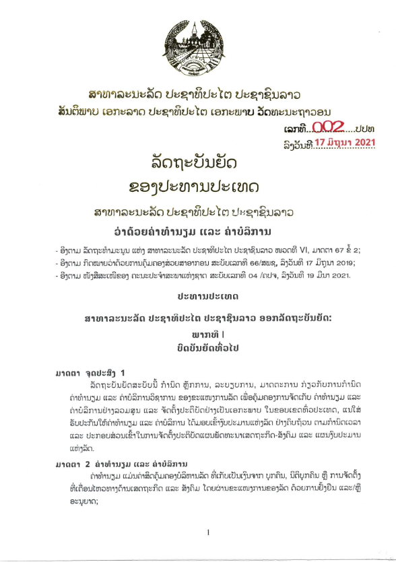
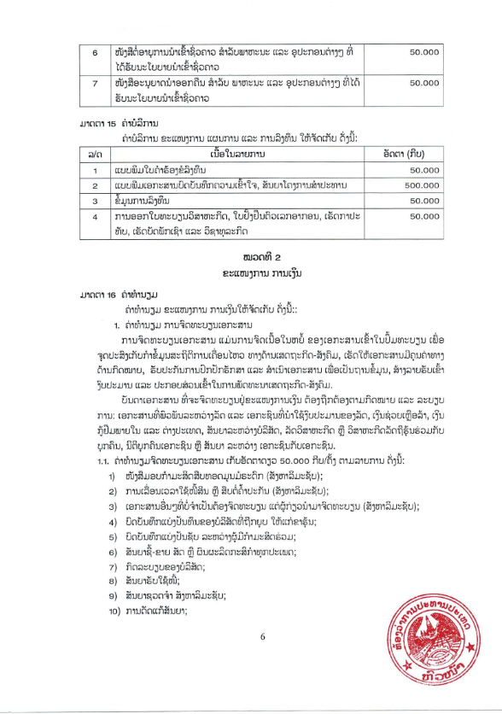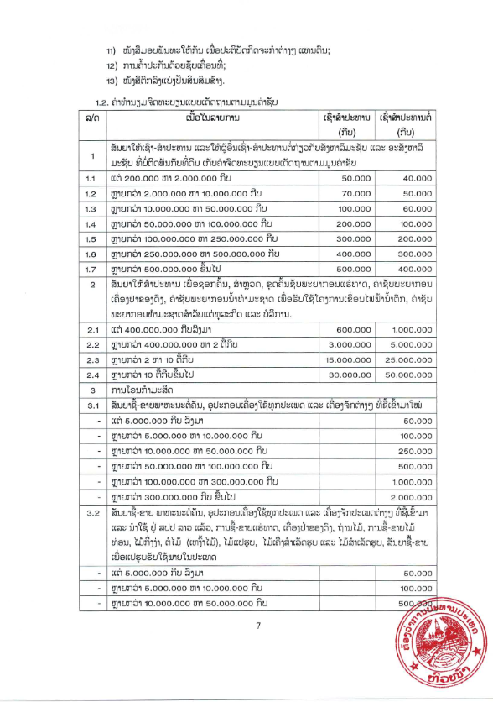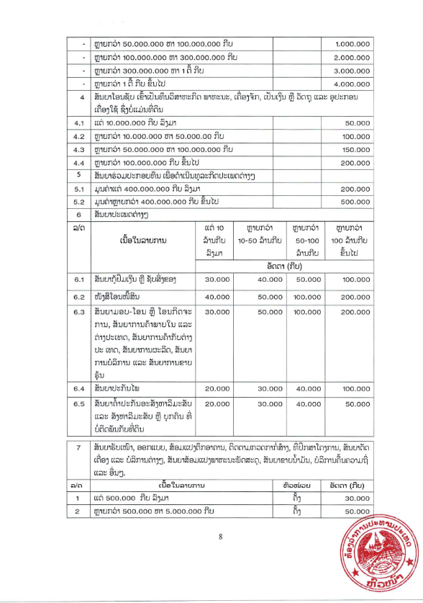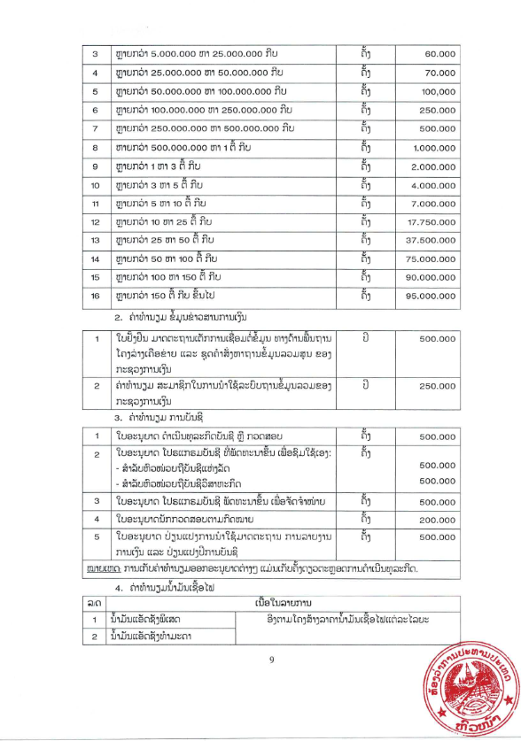
Section 6: Technical Specification and Work Schedule

A. Technical Specification

A set of precise and clear specifications is a prerequisite for Bidders to respond realistically and competitively to the requirements of the Procuring Entity without introducing deviations or conditionalities in their Quotations. In the context of price comparison, the specifications shall be drafted to permit the widest possible competition and, at the same time, present a clear statement of the required standards of workmanship, materials, and performance of the works to be procured. Only if this is done, the objectives of the procurement will be fulfilled as a result of economy, efficiency and fairness in procurement be realized, responsiveness of Quotations be ensured, and the subsequent task of Quotation evaluation facilitated. The specifications should require that all goods and materials to be incorporated in the Works be new, unused, of the most recent or current models, and incorporate all recent improvements in design and materials, unless provided otherwise in the Contract.

Samples of specifications from previous similar projects are useful in this respect. Most specifications are normally written specially by the Procuring Entity or Engineer to suit the Contract Works in hand. There is no standard set of Specifications for universal application in all sectors, but there are established principles and practices, which are reflected in these documents.

There are considerable advantages in standardizing General Specifications for repetitive Works in recognized public sectors, such as highways, ports, railways, urban housing, irrigation, and water supply, where similar conditions prevail. The General Specifications should cover all classes of workmanship, materials, and equipment commonly used in construction, although not necessarily to be used in a particular Works Contract. Deletions or amendment should then adapt the General Specifications to the particular Works. Such General Specifications are those issued by the specialised ministries/professional bodies in Lao PDR and/or those of the International Standards Organisation (ISO).

These notes for preparing Specifications are intended only as information for the Procuring Entity or the person drafting the Quotation document. They should not be included in the final documents.

[For the ADB and World Bank financed contracts only]

Environmental and social requirements

[The Employer’s team preparing the ES requirements should include a suitably qualified Environmental and Social specialist/s.
In preparing detailed specifications for ES requirements the Borrower should refer to and consider the applicable environmental and social standards in the ESF including the specific requirements set out in the Environmental and Social Commitment Plan (ESCP), ESIA/ESA/ESMP, EHSGs and other GIIP as well as SEA and SH prevention and management obligations.
The ES requirements should be prepared in manner that does not conflict with the relevant General Conditions of Contract (and the corresponding Particular Conditions of Contract if any), and other parts of the Specification.
The following is a non-exhaustive list of Sub-Clauses of the Conditions of Contract that make reference to ES matters stated in the Specification.]
Sub-Clause /Clause No. | Sub-Clause/Clause | Remarks
8.2 | Other Contractors | Indicate specific aspects (if any) that require contractor’s cooperation such as to conduct environmental and social assessment.
9.4.1, 9.4.2, 9.4.7, 9.4.8 | labor | State applicable requirements in accordance with the labor management procedure.
9.4.6 | Facilities for Staff and Labor | -Indicate if access to or provision of services that accommodate physical, social and cultural needs of Contractor’s Personnel is required.
9.4.20 | Training of Contractor’s Personnel | As set out in the ESCP, specify, , details of any training to relevant Contractor’s Personnel to be provided by the Employer’s Personnel on environmental and social aspects. (whom, what, when, where, how long etc.)
15.2 | Contractor to Construct the Works | If the Contract specifies that the Contractor shall design any part of the Permanent Works, state any applicable technical standards and requirements including to address:  - climate change considerations,  - universal access,  - risks of the public’s potential exposure to operational accidents or natural hazards, including extreme weather events, applicable certification or approval requriements  [ Refer to ESS4 on requirements for design]
18.2 | Health and Safety Obligations | Indicate any additional requirements for the health and safety manual
18.3 | Protection of the Environment | Specify any values for emissions, surface discharges, effluent and any other pollutants from the Contractor’s activities that shall not be exceeded.
19.1 | Archeological and Geological Findings | Specify other requirements if any in accordance with the ESF – ESS8
29.1 | Security of the Site | State any additional requirements for the security arrangements (ESS4 of the ESF states the principles of proportionality, GIIP and applicable laws.) Include any other requirement set out in the ESCP.

In addition to provisions in the above table, the Employer shall specify the following as applicable.
Management and Safety of Hazardous Materials
As applicable, specify requirements for the management and safety of hazardous materials (see ESF - ESS4 para. 17 and 18 and relevant guidance notes).
Resource Efficiency and Pollution Prevention and Management
As applicable specify Resource Efficiency and Pollution Prevention and Management measures (see ESF -ESS3 and relevant guidance notes).
- Resource efficiency
The Employer shall specify, as applicable, measures for improving efficient consumption of energy, water and raw materials, as well as other resources.
- Energy: When the Works have been assessed to involve a potentially significant use of energy, specify any applicable measures to optimize energy usage.
- Water: When the Works have been assessed to involve a potentially significant use of water or will have potentially significant impacts on water quality, specify any applicable measures that avoid or minimize water usage so that the Works’ water use does not have significant adverse impacts on communities, other users and the environment.
- Raw material: When the Works have been assessed to involve a potentially significant use of raw materials, specify any applicable measures to support efficient use of raw materials.
- Pollution prevention and management
- Management of air pollution: specify any measure to avoid or minimize Works related air pollution. See also GCC Sub-Clause 18.3 and the table above on Conditions of Contract that make reference to ES matters in the Specification.
- Management of hazardous and nonhazardous wastes: specify any applicable measures to minimize the generation of waste, and reuse, recycle and recover waste in a manner that is safe for human health and the environment including storage, transportation and disposal of hazardous wastes. See also GCC Sub-Clauses 18.2 and 18.3 and the table above on Conditions of Contract that make reference to ES matters in the Specification.
- Management of chemicals and hazardous materials: specify any applicable measures to minimize and control the release and use of hazardous materials for Works activities including the production, transportation, handling, and storage of the materials. See also GCC Sub-Clauses 18.2 and 18.3 and the table above on Conditions of Contract that make reference to ES matters in the Specification.
- Biodiversity Conservation and Sustainable Management of Living Natural Resources
The Employer shall specify, as applicable, Biodiversity Conservation and Sustainable Management of Living Natural Resources (see ESF - ESS6 and relevant guidance notes). This includes, as applicable:
- invasive alien species: managing the risk of invasive alien species during the execution of the Works;
- sustainable management of living natural resources; and
- certification and verification requirements for the supply of natural resource materials where there is a risk of significant conversion or significant degradation of natural or critical habitats.
See also GCC Sub-Clause 18.3 and the table above on Conditions of Contract that make reference to ES matters in the Specification.
- Road Safety
- State any specific traffic and road safety requirement, as applicable. See also Sub-Clause 9.3 of the General Conditions of Contract. For details, refer to the Guidance Note on Road safety.

Payment for ES Requirements
The Employer’s ES and procurement specialists should consider how the Contractor will cost the delivery of the ES requirements. In the majority of cases, the payment for the delivery of ES requirements shall be a subsidiary obligation of the Contractor covered under the prices quoted for other Bill of Quantity items or activities. For example, normally the cost of implementing workplace safe systems of work, including the measures necessary for ensuring traffic safety, shall be covered by the Bidder’s rates for the relevant works. Alternatively, provisional sums could be set aside for discrete activities for example for HIV counselling service, and, GBV/SEA awareness and sensitization or to encourage the contractor to deliver additional ES outcomes beyond the requirement of the Contract.

B. Construction Program and Work Schedule

The contractor shall provide their proposal on construction methodology and work schedule in accordance with the technical specifications and completion time in the Request for Quotations.
Section 7: Drawings

Notes on Drawings

Insert here a list of Drawings. The actual Drawings, including site plans, should be attached to this section or annexed in a separate folder. The Drawings shall be dated, numbered and show the revision number.

Section 8: Contract Forms

This Section contains forms which, once completed, will form part of the Contract. The forms for Performance Security, when required, shall only be completed by the successful Bidder after contract award.

Table of Forms

Form 1: Notification of Intention to Award 3
Form 1 (a): Notification of Intention to Award (for state budget only) 7
Form 2: Beneficial Ownership Disclosure Form 9
Form 3: Notification of Award 11
Form 4: Contract Agreement 12
Form 5: Bank Guarantee for Performance Security 14
Form 6: Guarantee for supply of works and/or maintenance or services 15

[For WB/ADB Financed Contract]
Form 1: Notification of Intention to Award

Notification of Intention to Award
[This Notification of Intention to Award shall be sent to each Bidder that submitted a Bid.]
[Send this Notification to the Bidder’s Authorized Representative named in the Bidder Information Form]
For the attention of Bidder’s Authorized Representative
Name: [insert Authorized Representative’s name]
Address: [insert Authorized Representative’s Address]
Telephone: [insert Authorized Representative’s telephone]
Email Address: [insert Authorized Representative’s email address]
[IMPORTANT: insert the date that this Notification is transmitted to Bidders. The Notification must be sent to all Bidders simultaneously. This means on the same date and as close to the same time as possible.]
DATE OF TRANSMISSION: This Notification is sent by: [email/fax] on [date] (local time)
Notification of Intention to Award
Procuring Entity: [insert the name of the Procuring Entity]
Project: [insert name of project]
Contract title: [insert the name of the contract]
Country: [insert country where RFB is issued]
Loan No. /Credit No. / Grant No.: [insert reference number for loan/credit/grant]
RFB No: [insert RFB reference number from Procurement Plan]
This Notification of Intention to Award (Notification) notifies you of our decision to award the above contract. The transmission of this Notification begins the Standstill Period. During the Standstill Period you may:
- request a debriefing in relation to the evaluation of your Bid, and/or
- submit a Procurement-related Complaint in relation to the decision to award the contract.
- The successful Bidder
Name: | [insert name of successful Bidder]
Address: | [insert address of the successful Bidder]
Contract price: | [insert contract price of the successful Bid]
- Other Bidders [INSTRUCTIONS: insert names of all Bidders that submitted a Bid. If the Bid’s price was evaluated include the evaluated price as well as the Bid price as read out.]
Name of Bidder | Bid price | Evaluated Bid price  (if applicable)
[insert name] | [insert Bid price] | [insert evaluated price]
[insert name] | [insert Bid price] | [insert evaluated price]
[insert name] | [insert Bid price] | [insert evaluated price]
[insert name] | [insert Bid price] | [insert evaluated price]
[insert name] | [insert Bid price] | [insert evaluated price]
- Reason/s why your Bid was unsuccessful
[INSTRUCTIONS: State the reason/s why this Bidder’s Bid was unsuccessful. Do NOT include: (a) a point by point comparison with another Bidder’s Bid or (b) information that is marked confidential by the Bidder in its Bid.]
- How to request a debriefing
DEADLINE: The deadline to request a debriefing expires at midnight on [insert date] (local time).
You may request a debriefing in relation to the results of the evaluation of your Bid. If you decide to request a debriefing your written request must be made within three (3) Business Days of receipt of this Notification of Intention to Award.
Provide the contract name, reference number, name of the Bidder, contact details; and address the request for debriefing as follows:
Attention: [insert full name of person, if applicable]
Title/position: [insert title/position]
Agency: [insert name of Procuring Entity]
Email address: [insert email address]
Fax number: [insert fax number] delete if not used
If your request for a debriefing is received within the 3 Business Days deadline, we will provide the debriefing within five (5) Business Days of receipt of your request. If we are unable to provide the debriefing within this period, the Standstill Period shall be extended by five (5) Business Days after the date that the debriefing is provided. If this happens, we will notify you and confirm the date that the extended Standstill Period will end.
The debriefing may be in writing, by phone, video conference call or in person. We shall promptly advise you in writing how the debriefing will take place and confirm the date and time.
If the deadline to request a debriefing has expired, you may still request a debriefing. In this case, we will provide the debriefing as soon as practicable, and normally no later than fifteen (15) Business Days from the date of publication of the Contract Award Notice.
- How to make a complaint
Period: Procurement-related Complaint challenging the decision to award shall be submitted by midnight, [insert date] (local time).
Provide the contract name, reference number, name of the Bidder, contact details; and address the Procurement-related Complaint as follows:
Attention: [insert full name of person, if applicable]
Title/position: [insert title/position]
Agency: [insert name of Procuring Entity]
Email address: [insert email address]
Fax number: [insert fax number] delete if not used
At this point in the procurement process, you may submit a Procurement-related Complaint challenging the decision to award the contract. You do not need to have requested, or received, a debriefing before making this complaint. Your complaint must be submitted within the Standstill Period and received by us before the Standstill Period ends.
Further information:
For more information see the Procurement Regulations for IPF Borrowers (Procurement Regulations)[https://policies.worldbank.org/sites/ppf3/PPFDocuments/Forms/DispPage.aspx?docid=4005] (Annex III). You should read these provisions before preparing and submitting your complaint. In addition, the World Bank’s Guidance “How to make a Procurement-related Complaint” [http://www.worldbank.org/en/projects-operations/products-and-services/brief/procurement-new-framework#framework] provides a useful explanation of the process, as well as a sample letter of complaint.
In summary, there are four essential requirements:
- You must be an ‘interested party’. In this case, that means a Bidder who submitted a Bid in this bidding process and is the recipient of a Notification of Intention to Award.
- The complaint can only challenge the decision to award the contract.
- You must submit the complaint within the period stated above.
- You must include, in your complaint, all of the information required by the Procurement Regulations (as described in Annex III).
- Standstill Period
DEADLINE: The Standstill Period is due to end at midnight on [insert date] (local time).
The Standstill Period lasts ten (10) Business Days after the date of transmission of this Notification of Intention to Award.
The Standstill Period may be extended as stated in Section 4 above.
If you have any questions regarding this Notification, please do not hesitate to contact us.
On behalf of the Procuring Entity:
Signature: ______________________________________________
Name: ______________________________________________
Title/position: ______________________________________________
Telephone: ______________________________________________
Email: ______________________________________________
Form 2 (a): Notification of Intention to Award (for state budget only)

Lao People's Democratic Republic
Peace, independence, democracy, unity, lasting culture
Ministry .........................
Department .............................................
Name of Procuring Entity No. / ......
Vientiane Capital, Date
Notification of Award
[This Notification to successful and non-successful Bidders]
[Send this Notification to the Bidder’s Authorized Representative named in the Bidder Information Form]
For the attention of Bidder’s Authorized Representative
Name: [insert Authorized Representative’s name]
Address: [insert Authorized Representative’s Address]
Telephone [insert Authorized Representative’s telephone]
Email Address: [insert Authorized Representative’s email address]
[IMPORTANT: insert the date that this Notification is transmitted to Bidders. The Notification must be sent to all Bidders simultaneously. This means on the same date and as close to the same time as possible.]
DATE OF TRANSMISSION: This Notification is sent by: [email] on [date] [local time]

- According to the evaluation report No……………………………………………….
- According to the minutes of the meeting to approve the results of the bidding.
The Procurement Committee of [the Ministry or Department or the name of the project] would like to inform you about the results of the Procurement of [Name of the works], where the quotations were opened on [date] ........... Details are as follows:
The Successful Bidder

Name | Address | Contract Price

Other Bidders
Items | ​Name of /Bidders | ​Opening Bid Prices | ​Evaluation Prices | ​The Result | ​The reason of Failure
1
2
3
4

The Tender Committee of [ the Ministry or the Department or the name of the project owner] would like to thank all the Bidders that participated in this Procurement and we welcome you to express interest on future procurement opportunities.

The successful Bidder must sign a contract within 14 days.

If you have any concerns or do not feel that the results of the above assessment and decision to be fair, you can file a formal letter to the Tender Committee of [the Ministry or Department or the name of the project owner] within 14 days of this notice. The complaints should be made in accordance with on the Law on Public Procurement and Instruction of Implementation of Law on Public Procurement, if the overdue complaint is deemed ineffective or not considered.

Chairman of the Procurement Committee
[For WB AND ADB Financed Contract]

Form 3: Beneficial Ownership Disclosure Form

Lao People's Democratic Republic
Peace Independence Democracy Unity Prosperity

Beneficial Ownership Disclosure Form
INSTRUCTIONS TO BIDDERS: DELETE THIS BOX ONCE YOU HAVE COMPLETED THE FORM

This Beneficial Ownership Disclosure Form (“Form”) is to be completed by the successful Bidder. In case of joint venture, the Bidder must submit a separate Form for each member. The beneficial ownership information to be submitted in this Form shall be current as of the date of its submission.

For the purposes of this Form, a Beneficial Owner of a Bidder is any natural person who ultimately owns or controls the Bidder by meeting one or more of the following conditions:

- directly or indirectly holding 25% or more of the shares
- directly or indirectly holding 25% or more of the voting rights
- directly or indirectly having the right to appoint a majority of the board of directors or equivalent governing body of the Bidder

RFQ No.: [insert number of RFQ process]
Request for Quotation No.: [insert identification]

To: [insert complete name of Procuring Entity]

In response to your request in the Letter of Acceptance dated [insert date of letter of Acceptance] to furnish additional information on beneficial ownership: [select one option as applicable and delete the options that are not applicable]

(i) we hereby provide the following beneficial ownership information.

Details of beneficial ownership

Identity of Beneficial Owner | Directly or indirectly holding 25% or more of the shares  (Yes / No) | Directly or indirectly holding 25 % or more of the Voting Rights  (Yes / No) | Directly or indirectly having the right to appoint a majority of the board of the directors or an equivalent governing body of the Bidder (Yes / No)
[include full name (last, middle, first), nationality, country of residence]

OR

(ii) We declare that there is no Beneficial Owner meeting one or more of the following conditions:

- directly or indirectly holding 25% or more of the shares
- directly or indirectly holding 25% or more of the voting rights
- directly or indirectly having the right to appoint a majority of the board of directors or equivalent governing body of the Bidder
OR

(iii) We declare that we are unable to identify any Beneficial Owner meeting one or more of the following conditions. [If this option is selected, the Bidder shall provide explanation on why it is unable to identify any Beneficial Owner]
- directly or indirectly holding 25% or more of the shares
- directly or indirectly holding 25% or more of the voting rights
- directly or indirectly having the right to appoint a majority of the board of directors or equivalent governing body of the Bidder]”

Name of the Bidder: *[insert complete name of the Bidder]

Name of the person duly authorized to sign the Bid on behalf of the Bidder: **[insert complete name of person duly authorized to sign the Bid]

Title of the person signing the Bid: [insert complete title of the person signing the Bid]

Signature of the person named above: [insert signature of person whose name and capacity are shown above]

Date signed [insert date of signing] day of [insert month], [insert year]

* In the case of the Bid submitted by a Joint Venture specify the name of the Joint Venture as Bidder. In the event that the Bidder is a joint venture, each reference to “Bidder” in the Beneficial Ownership Disclosure Form (including this Introduction thereto) shall be read to refer to the joint venture member.
** Person signing the Bid shall have the power of attorney given by the Bidder. The power of attorney shall be attached with the Bid Schedules.

Form 4: Notification of Award

Lao People's Democratic Republic
Peace Independence Democracy Unity Prosperity

Notification of Award

Contract No: | Date:
To:

[enter name of Contractor]

This is to notify you that your quotation dated [insert date] for the execution of the Works for [name of project/Contract] for the Contract Price of Kip [amount in figures and words], as corrected and modified in accordance with the Instructions to Bidders is hereby accepted by [name of the Procuring Entity].

You are requested to proceed with the execution of the Works on the basis that this Notification of Award shall constitute the formation of a Contract, which shall only become binding upon you furnishing a Performance Security and an Environmental and Social Performance Security [Delete ES Performance Security if it is not required under the contract] within fourteen (14) days, in accordance with ITB 20.

We attach the Contract Agreement and Conditions of Contract for your perusal and signature.

Signature(s)
Duly authorised to sign for and on behalf of [Procuring Entity]

Form 5: Contract Agreement

Lao People's Democratic Republic
Peace Independence Democracy Unity Prosperity
Contract Agreement

THIS AGREEMENT made the [day] day of [month] [year] between [name and address of the Procuring Entity] (hereinafter called “the Procuring Entity”) of the one part and [name and address of Contractor] (hereinafter called “the Contractor”) of the other part:

WHEREAS the Procuring Entity is desirous that the Contractor execute [name and identification No. of Contract] (hereinafter called “the Works”) and has accepted a bid by the Contractor for the execution and completion of such Works and the remedying of any defects therein in the sum of Kip [Contract Price in figures and in words] (hereinafter called “the Contract Price”).

NOW THIS AGREEMENT WITNESSETH AS FOLLOWS:

Article 1. The documents forming the Contract shall be interpreted in the following order of priority:
- the signed Contract Agreement;
- the Conditions of Contract;
- the letter of Notification of Award;
- the completed quotation Submission Sheet as submitted by the Bidder;
- the priced Schedule of Activities as submitted by the Bidder and corrections if applicable;
- the Technical Specifications and Work schedule;
- the Drawings.

Article 2. In consideration of the payments to be made by the Procuring Entity to the Contractor as hereinafter mentioned, the Contractor hereby covenants with the Procuring Entity to execute and complete the works and to remedy any defects therein in conformity in all respects with the provisions of the Contract.

Article 3. The Procuring Entity hereby covenants to pay the Contractor in consideration of the execution and completion of the works and the remedying of defects therein, the Contract Price or such other sum as may become payable under the provisions of the Contract at the times and in the manner prescribed by the Contract.

IN WITNESS whereof the parties hereto have caused this Agreement to be executed in accordance with the laws of Lao PDR on the day, month and year first written above.

Signed, Sealed and delivered by the said Signed, Sealed and delivered by the said

In the presence of (for Procuring Entity) In the presence of (for Contractor)

Witness:
…………………………….. …………………………………...

Form 6: Bank Guarantee for Performance Security

Bank’s Name and Address of issuing branch or office:

Date:

PERFORMANCE GUARANTEES No:

We have been informed that [name of Contractor] (hereinafter called “the Contractor”) has entered into Contract No. [reference number of Contract] dated [date of Contract] (hereinafter called “the Contract”) for the execution of [description of works].

Furthermore, we understand that, according to your conditions, Contracts must be supported by a Performance Guarantee.

At the request of the Contractor, we [name of bank] hereby irrevocably undertake to pay you, without cavil or argument, any sum or sums not exceeding in total an amount of Kip [insert amount in figures and words approximately equivalent to 10% of the estimated cost of the procurement] upon receipt by us of your first written statement that the Contractor is in breach of its obligation(s) under the Contract Conditions, without the need to prove or show grounds or reasons for your demand of the sum specified therein.

This guarantee is valid until [date of validity of guarantee], consequently, we must receive at the address noted above a written request for payment on or before the aforementioned date.

Signature(s)

Authorized Representative(s) of Bank

Form 7: Guarantee for supply of works and/or maintenance or services

[FOR STATE BUDGET ONLY]

GUARANTEE FOR SUPPLY OF WORKS AND/OR MAINTENANCE OR SERVICES

Bank’s Name and Address of issuing branch or office Date:
No:

Beneficiary: Name and Address of the Project Owner,

We have been informed that [name of Constructor] (hereinafter called “the Contractor”) intends to submit to you its Quotation dated [date of quotation] (hereinafter called “the Quotation”) for the supply of [Work and related Services] under the above Invitation for Quotation (hereinafter called “the IFB”).

Furthermore, we understand that, according to your conditions Quotations must be supported by a Guarantee for the supply of Works and/or maintenance or services.

At the request of the Contractor, we [name of bank] hereby irrevocably undertake to pay you, without objection or argument, the sum of [insert amount in figures and words in Kip] upon receipt by us of your first written statement that the Contractor is in breach of its obligation(s) under the Contract Conditions,

We keep a copy of the Performance Guarantee for the supply of Works and/or maintenance or services and a copy of the Contract signed by the Bidder as issued by you.

This guarantee is valid until [date of validity of guarantee], consequently, we must receive at the address noted above a written request for payment on or before the aforementioned date.

Signature(s) of authorized representative(s) of Bank

Ministry of Finance
State Assets Management Department
Road 23 Singha, Vientiane Capital, Lao PDR
Tel/Fax: (856-21) 263252
www.ppd.mof.gov.la

For the avoidance of doubt, a sanctioned party’s ineligibility to be awarded a contract shall include, without limitation, (i) applying for pre-qualification, expressing interest in a consultancy, and bidding, either directly or as a nominated sub-contractor, nominated consultant, nominated manufacturer or supplier, or nominated service provider, in respect of such contract, and (ii) entering into an addendum or amendment introducing a material modification to any existing contract.
A nominated sub-contractor, nominated consultant, nominated manufacturer or supplier, or nominated service provider (different names are used depending on the particular bidding document) is one which has been: (i) included by the bidder in its pre-qualification application or bid because it brings specific and critical experience and know-how that allow the bidder to meet the qualification requirements for the particular bid; or (ii) appointed by the Borrower.
Inspections in this context usually are investigative (i.e., forensic) in nature. They involve fact-finding activities undertaken by the Bank or persons appointed by the Bank to address specific matters related to investigations/audits, such as evaluating the veracity of an allegation of possible Fraud and Corruption, through the appropriate mechanisms. Such activity includes but is not limited to: accessing and examining a firm's or individual's financial records and information, and making copies thereof as relevant; accessing and examining any other documents, data and information (whether in hard copy or electronic format) deemed relevant for the investigation/audit, and making copies thereof as relevant; interviewing staff and other relevant individuals; performing physical inspections and site visits; and obtaining third party verification of information.
For the avoidance of doubt, a sanctioned party’s ineligibility to be awarded a contract shall include, without limitation, (i) applying for pre-qualification, expressing interest in a consultancy, and bidding, either directly or as a nominated sub-contractor, nominated consultant, nominated manufacturer or supplier, or nominated service provider, in respect of such contract, and (ii) entering into an addendum or amendment introducing a material modification to any existing contract.
A nominated sub-contractor, nominated consultant, nominated manufacturer or supplier, or nominated service provider (different names are used depending on the particular bidding document) is one which has been: (i) included by the bidder in its pre-qualification application or bid because it brings specific and critical experience and know-how that allow the bidder to meet the qualification requirements for the particular bid; or (ii) appointed by the Borrower.
Inspections in this context usually are investigative (i.e., forensic) in nature. They involve fact-finding activities undertaken by the Bank or persons appointed by the Bank to address specific matters related to investigations/audits, such as evaluating the veracity of an allegation of possible Fraud and Corruption, through the appropriate mechanisms. Such activity includes but is not limited to: accessing and examining a firm's or individual's financial records and information, and making copies thereof as relevant; accessing and examining any other documents, data and information (whether in hard copy or electronic format) deemed relevant for the investigation/audit, and making copies thereof as relevant; interviewing staff and other relevant individuals; performing physical inspections and site visits; and obtaining third party verification of information.
Note: If performance security is not applied, this percentage can be reduced to 20% and the remaining 10% will be paid upon expiration of the defect liability period.
The option to remove/not remove shall be consulted by the Bank’s ES team/specialist.
Contract registration fee is in accordance with Ordinances of the President No.002 in the attachment

